# Creation Website Comments

*All completed tasks have been marked in green by CGTL.

## Common

1. Update menu on **all pages** to include “News” between Associates and Careers



## Latest News

1. Make “Post: Date” link to respective news page.

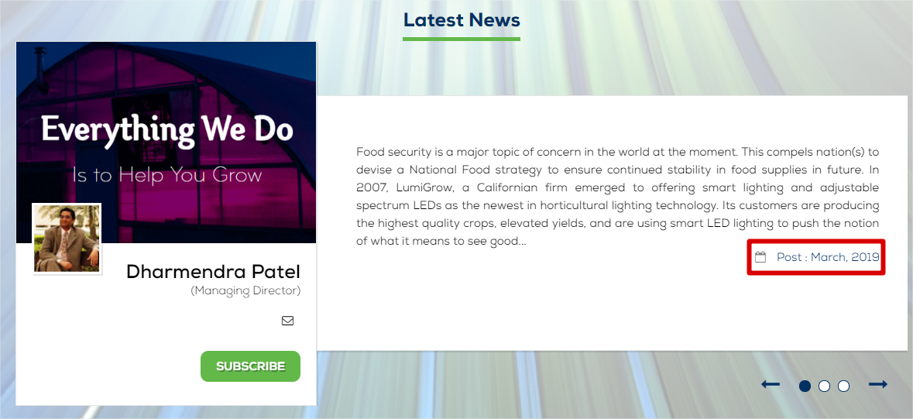

1. Add empty line between the short description <p> tag and date <div tag>

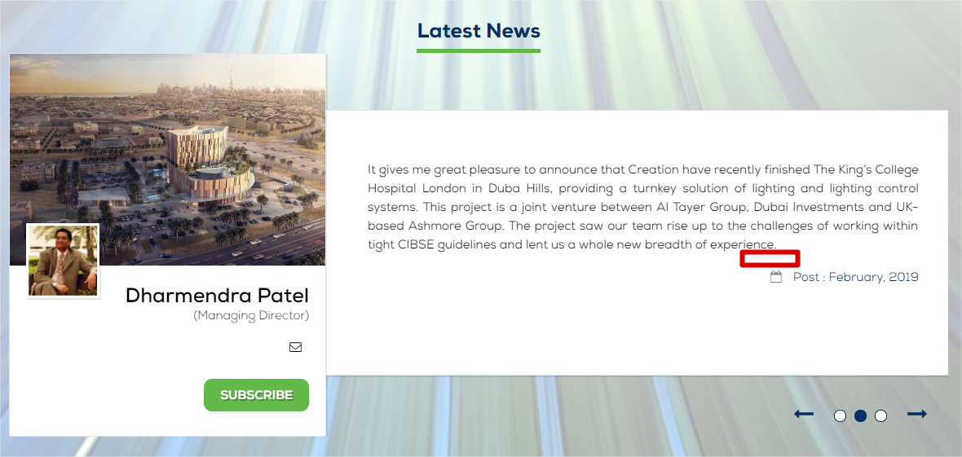

1. Continuous scroll Latest News items with interval of 30 seconds for each news. Maintain maximum visible news as current which is 3.

## Latest News

1. Is it possible to add vanity URLS for the news that I upload? Right now, it is passing parameters which are visible.
   1. CGTL is still checking for this.
2. I understand this is repeat change, apologies for the same. Please adjust the news page Title (1) and Date (2 -> left aligned) as below:

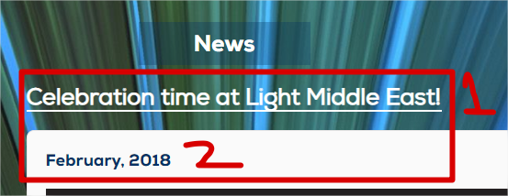

1. When I click on any link from the left Archive Menu, the extendable <div> hides and then re-appears upon page load. Is there a way to avoid this? Or make it less obvious?

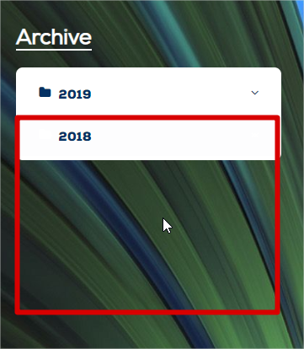

1. The 2018 - folder image always remains white. Please fix.

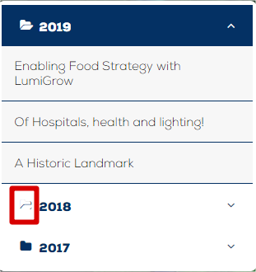

1. Page Title to be displayed as image below:

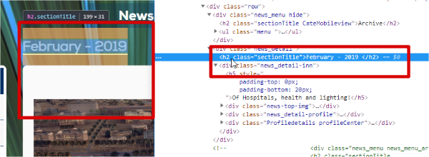

1. Newsletter Heading padding to be adjusted as below:

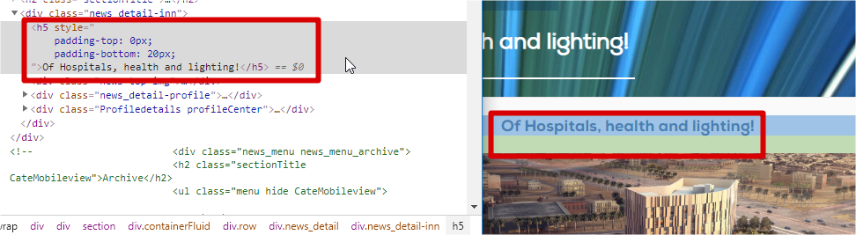

1. News left panel Archive Menu to be adjust as in image below:

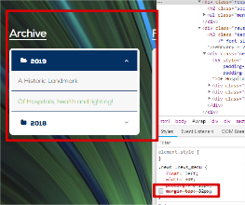

1. In the below images will see the difference in the actual design and the website design. The new line should not happen. I do not know where it is getting added from.

Reference pages:

* 1. <http://www.creationgulf.com/news.php?id=29&main=1>
  2. <http://www.creationgulf.com/news.php?id=33&main=1>

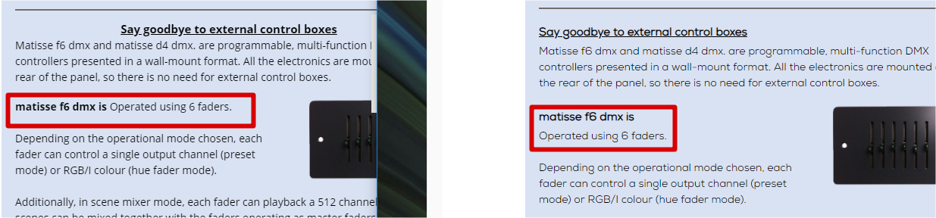

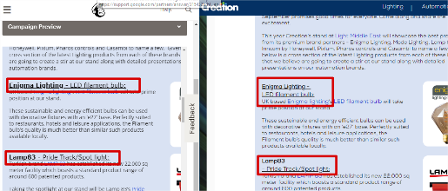

1. There is an &nbsp; getting added in many pages, below is one sample on page <http://www.creationgulf.com/news.php?id=30&main=1>

