**Manage Library**

<http://dev6.wethedevelopers.com/MatthewYoung/final/siteadmin/add_library.php>

1. in “Upload ” section add “Name ” and upload button ,when user enter both and click on “+” provide another name + upload document field

**=> aa atyare na karai client kese to aapde karasu because badha ma same j rakhyu chhe atle**

1. add error message if document is not selected
2. in edit add error message if no document is added

<http://dev6.wethedevelopers.com/MatthewYoung/final/siteadmin/add_company_manager.php>

1. in “Sales Contact” ->From where ”Sales phone” detail came from ,....because there is no such type of field in “Administrator”

**=> Administrator => Mobile No  nu field chhe ano data aave chhe**

→ **Please display this field in ‘Sales mobile’ instead of ‘sales phone’**

1. add validation for “Sales contact” details -> add validation for user name and postcode fields

**Manage Give away Company** <http://dev6.wethedevelopers.com/MatthewYoung/final/siteadmin/add_giveaway.php>

1. add error message if product image is not selected -> do the same for ‘Edit Give away company’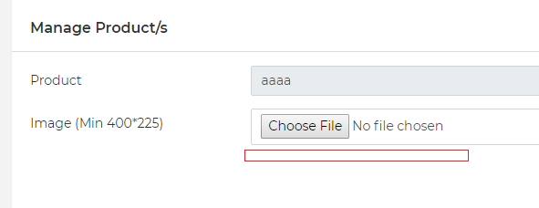

**Manage Give away Inventory**

<http://dev6.wethedevelopers.com/MatthewYoung/final/siteadmin/manage_giveawayinventory.php>

1. remove archived company from  “Select Company ” dropdown

**Manage Administrator**

<http://dev6.wethedevelopers.com/MatthewYoung/final/siteadmin/add_administrator.php>

1. “Network Permission” and “Send User Invitation”  is missing.
2. in “Document” section , there should be three field Document name, expiry date and Upload document together and when user click on “+” button these 3 field should replicate.

**=> aa atyare na karai client kese to aapde karasu because badha ma same j rakhyu chhe atle**

1. please only allow digits in mobile number fields -> change error message to ‘Please enter digits’ if user enters texts

<http://dev6.wethedevelopers.com/MatthewYoung/final/siteadmin/edit_administrator.php?id=Mg==>

1. for one user “Document name” should be unique
2. add error message for document name.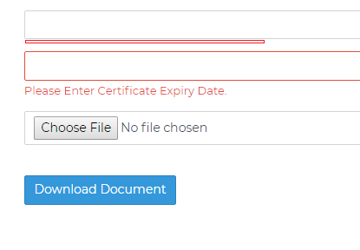
3. it allow to save details even if Document is not selected.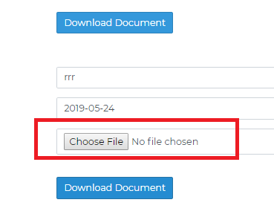

**Manage Unit block**

[**http://dev6.wethedevelopers.com/MatthewYoung/final/siteadmin/add\_unit\_block.php**](http://dev6.wethedevelopers.com/MatthewYoung/final/siteadmin/add_unit_block.php)

1. Search functionality is not working

one block should not contain same unit twice or more.

**Manage Block Offer**

<http://dev6.wethedevelopers.com/MatthewYoung/final/siteadmin/edit_unit_block.php?id=MQ==>

1. when error at least one unit should be selected.

**Manage Trainer**

<http://dev6.wethedevelopers.com/MatthewYoung/final/siteadmin/add_trainer.php>

1. if “Trainer is Superviser” option is checked ,add error message for “Select Category”, “Select Industry” and “Select Other Trainer This Trainer Supervises” fields.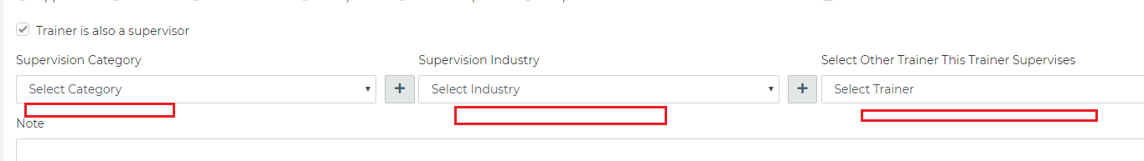
2. Trainers Qualification is compulsory
3. “Current employment contract ” is Heading so make text bold, remove checkbox, all details in it is mandatory and only digit and dot. should allow in “Rate for quoting” field allow.

--------------------------------------------------------------------------------------------------------------------------------

**Front-End**

**General**

1. web and mobile view = Whichever tab is open should be selected in menu
2. in footer click in New slider is not working as in design.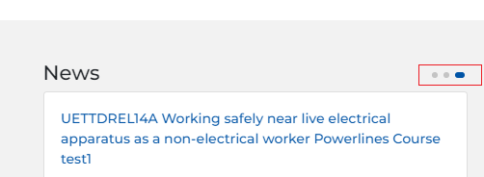
3. in “our Clients” section this dots are missing.**Design**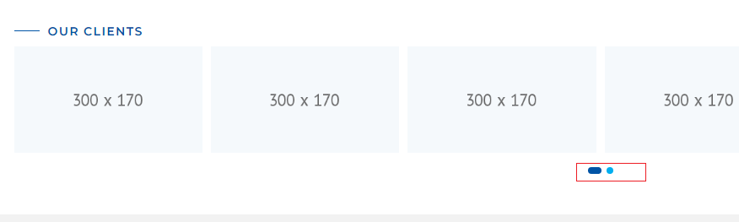

**Sign-Up pop up**

<http://dev6.wethedevelopers.com/MatthewYoung/final/>

1. put error message after text.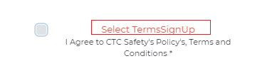
2. remove link on “Yes, send me CTC Safety Course Date and Offers” text. -> Please remove the LINK on the text, NOT TEXTS. Please keep texts as it was before  
   
3. discuss “Current company you work for”
4. Organization user ->put error message for Terms and condition after text.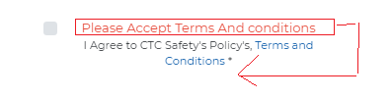
5. Organization user ->text after DOB and secondary email fields are missing.

**Forgot password**

1. when you 1st entered id then select type  it gives error message “Email does not exists.”

**Login**

1. change placeholder for this field to “Password”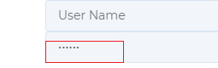

<http://dev6.wethedevelopers.com/MatthewYoung/final/careers>

1. please put error messages outside of fields.
2. put error message after field.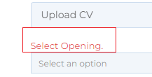and change message to “Select option”
3. phone number field should only allow digits.
4. selected file name is not displayed in  “upload cv” and “upload qualification”.
5. “select option” field should not be compulsory.

<http://dev6.wethedevelopers.com/MatthewYoung/final/resources>

1. Display documents/links in same order as they were added in admin  library

**Course Detail**

[http://dev6.wethedevelopers.com/MatthewYoung/final/course-details/Ng==/1/Mjg=#course\_dates](http://dev6.wethedevelopers.com/MatthewYoung/final/course-details/Ng==/1/Mjg=" \l "course_dates)

1. in group booking email id should be distinct from each other

<http://dev6.wethedevelopers.com/MatthewYoung/final/booking-terms/OQ==/1/MjAxOS0wNi0yOA==/Nw==/Nw==/MjM=>

1. sign up pop up -> mobile number and phone number , allow digits only
2. sign up pop up ek vaar close kari open kari pa6i organization and individual sign up na fields same aave chhe.
3. once you fill some details and close sign up pop up and again open pop up it displayed previously filled details.