**UAT findings:**

**3. Order**

**(b) New Invoice:**

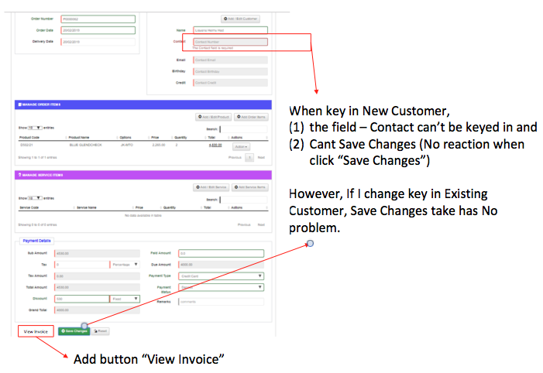 **-** Add button “View Invoice” beside “Save Changes”

* When key in New Customer:
* Input field “Contact” cannot keyed in
* Click “Save Changes” button has no reaction. (noted only allow to Save Changes if keyed in Existing Customer)

**Q. Before submission it should be view invoice?** Yes.

**(c) Add/Edit Order Items**

* Order Product that entitled for point collection, but point not added to customer. → **Where?** -> Refer Process>Product>Add Product: there is a field for “Point”, user will input points if this product entitle for points collection.
* 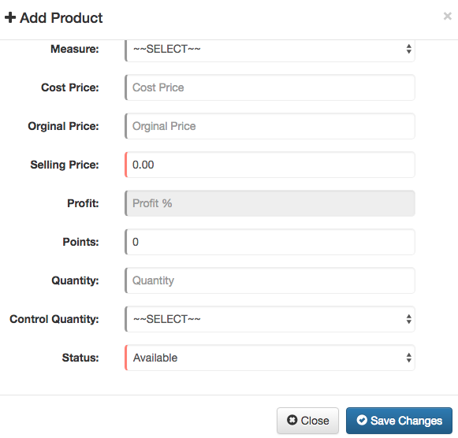

So, when come to order item, Orders>New Invoice>Add Order Item: if select this product, customer will have points collected. Refer customer page here

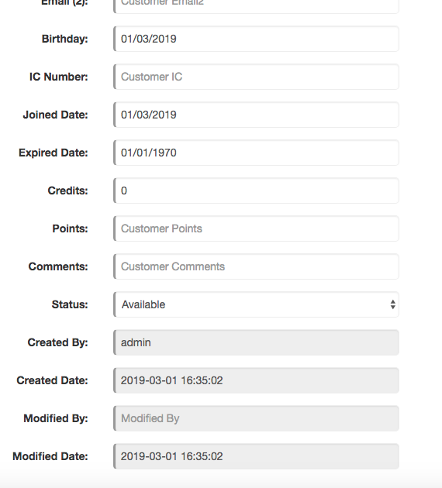

**(d) Payment Details:**

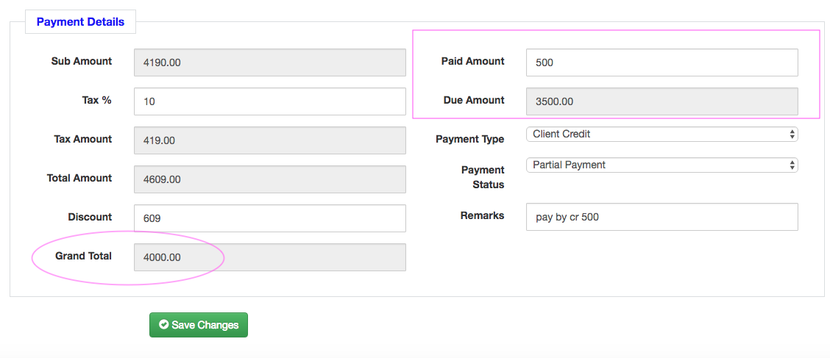

* After “Total Amount” should have “Coupon” field to cater for Coupon for overall discount, for example for Birthday etc.
* Input of coupon for Birthday, system should check against customer birthday month.  **→ How we get the birth date?** Refer Process>Customer>Add Customer:Birthday field
* Customer client credit only 500, but system allow to pay by Client Credit more than 500, system Should check whether sufficient credit to use. → **Where it is do?** In [Order>New Invoice] and

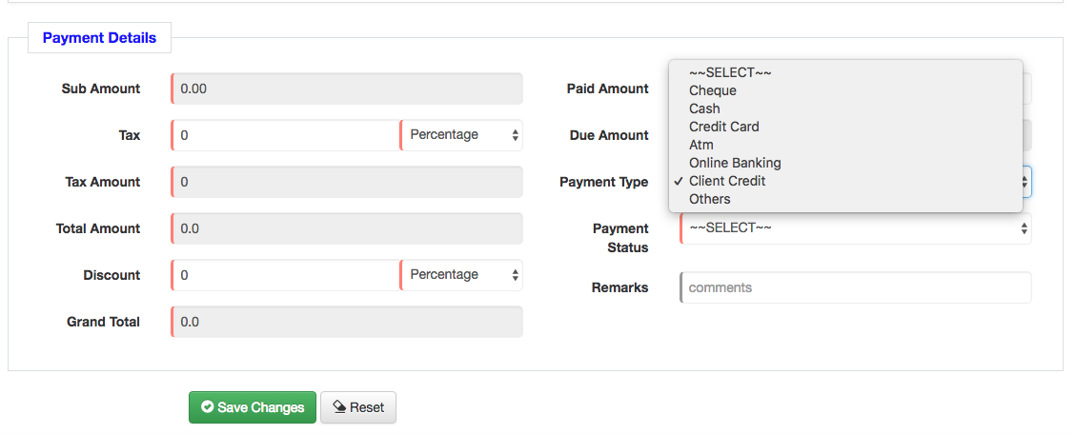

[Orders>Manage Orders> Action> Payment]

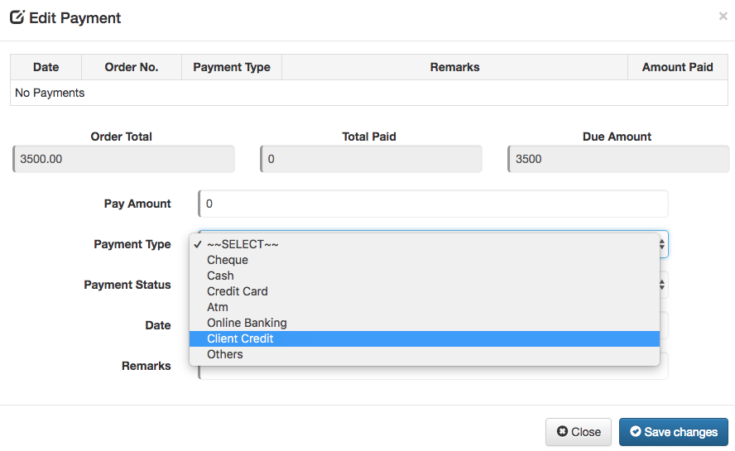

* Client credit used not deducted from customer accordingly.
* If order was removed, should add client credit back to customer.

1. **Order Removed**

When order was removed, all related items payments, client credit used and product

points given should be reversed and adjusted accordingly: **→ Where ->** refer below

* Total payment shown in dashboard should adjusted accordingly, [In Dashboard]

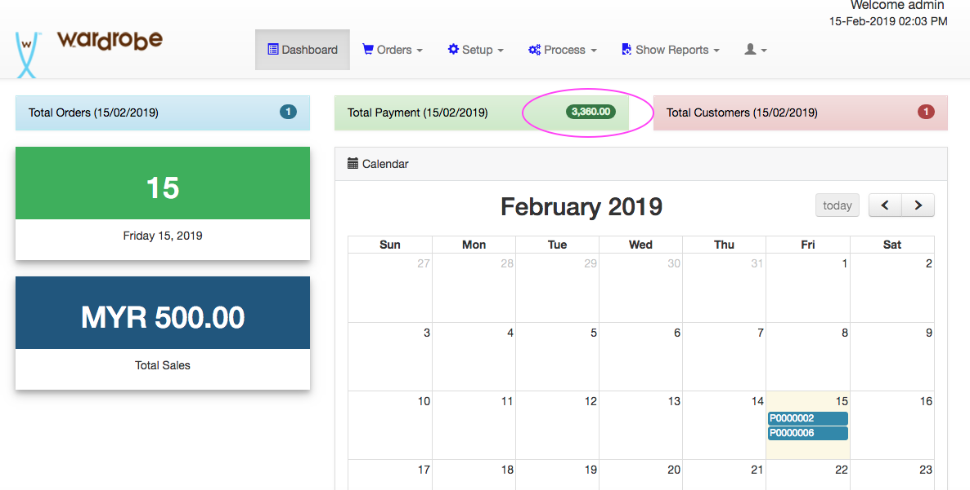

* Payment List should show those payments of order being removed, [In Show Reports > Payment List]

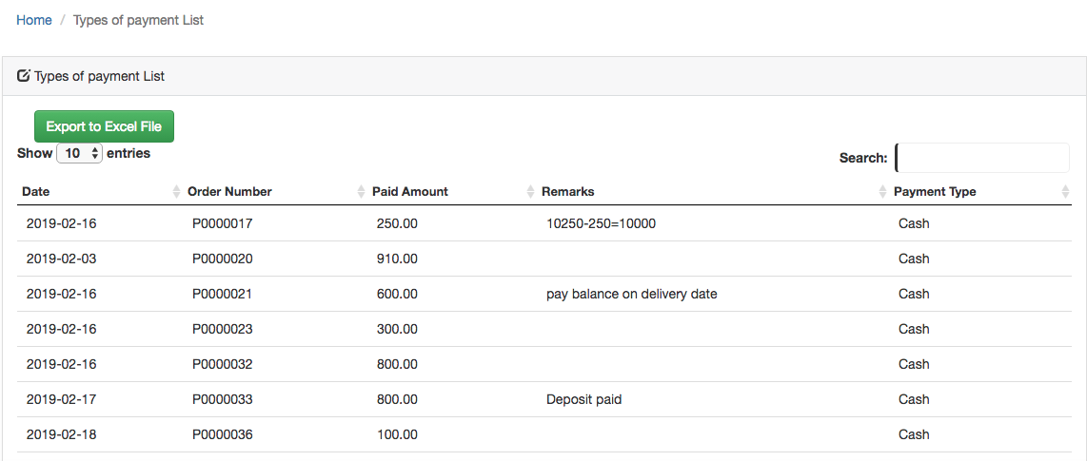

* Customer Client Credit used (if any) should refunded to customer, [In Process> Customer]
* 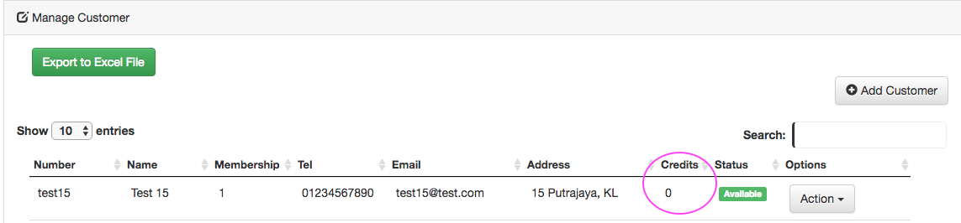

* Product points (if that product entitled for points collection) collected by customer should remove from customer. [In Process> Customer]

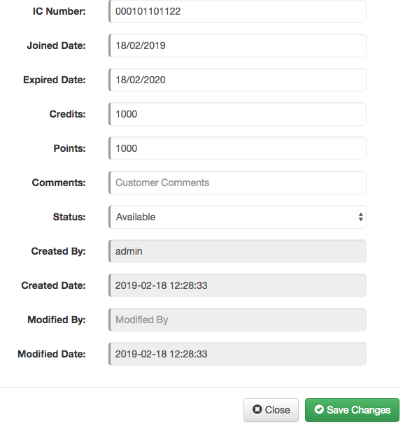

**4. Customer**

**(a) Customer - Add/Edit**

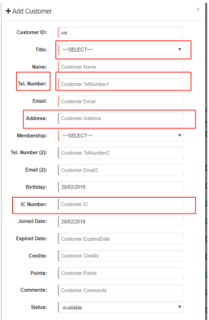

* Title - Dropdown list should show full list. To allow user to self maintain the list.

**Q. Drop down is already there which list should show full?** User need to add more in the “Title” dropdown list. Perhaps user can self maintain the list.

**(b) Order History**

To allow sales person to click shortcut link to view customer Order History on special request to take note.

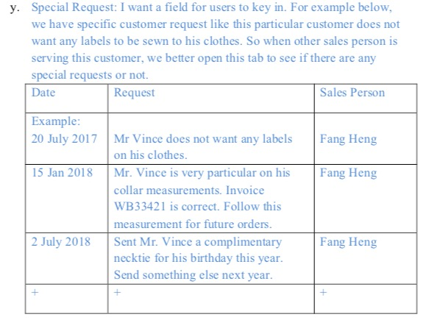

**5. Dashboard**

* To add field “Status” for total ordered product / services for today and click link to
* navigate to Ordered Products page.

i.e. Total for each status. Currently we don’t have any report or listing yet.. so

system should able to show all status by different date or filter. For example:

* Order Item Status: Collected, pending. (show Status for Collected how many? Pending how many ?) and,
* Service Item Status: Ready, Fitting, Delivered, pending. (show Status Ready how many? Fitting how many ? etc..)

**6. Control payment based on status → Where?** In Orders>New Invoice> Add Order

Items & In Orders>New Invoice> Add Service Items & Orders>Manage Order>Edit; both Order Item and Service Item will have Status field.

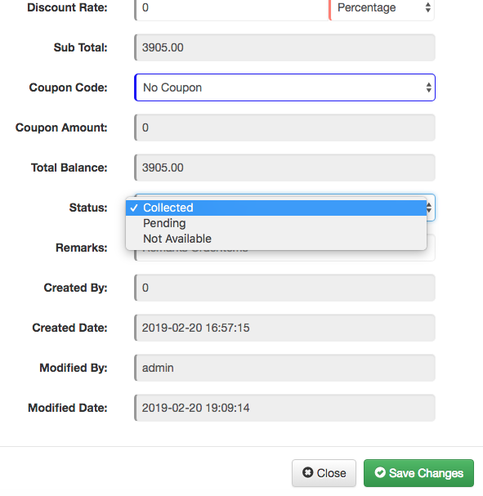

Set the conditions so that payment must be made based on what have been

Collected/delivered for Order Item and Service Item. Allow user to self maintan the status list for both Order Item & Service Item, and allow user to tag which status to

control payment amount.

-> Explanation: Item must be paid before or upon collection.

For eg. An order has a shirt cost rm500 and a vest cost rm300. If the customer collects

the vest then the payment collected must be at least rm300.

i.e. To control on how much needs to be pay upon items collected or delivered.

*Note: As per Spec:*

*- Partial Delivery and Multiple Deposits*

* 1. *(a) Deposit is required for each sales order and delivery. This is to ensure that the sales amount for the items delivered is fully settled and deposit is required for the outstanding items to be delivered. In such scenario, there may have few partial deliveries and multiple deposits at the different time and date in one sales order.*
  2. *(b) Require to indicate “Delivered or delivery date” for those delivered items in one sales order.*
  3. *(c) Able to recall back the sales order and select the item for status update (dropdown list) as*
  4. *ready, 1st fitting, 2nd fitting, 3rd fitting & delivered.*
  5. *(d) Express delivery will have additional charges (additional charge for e.g. 1day $300, 3 days $150, 5 days $100)*

***Note : Please provide all the points with screenshots***