**UAT findings:**

**1. Product:**

- To show no. of record for each pages just like others. Example: “Showing 1 to 10 of 9016 entries”.

- There is last page 903 shown, but click on it nothing was listed.

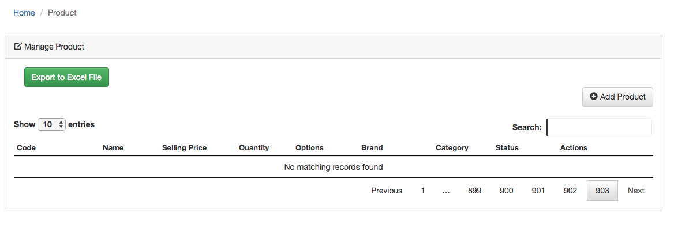

- Not able to upload max up to 5 pictures, only 1 file was saved. Should allow upload up to 5 files and file size limit is 5MB, and put a notes on this as a guide to user.

**2. Service:**

* Should not set Image field as mandatory, and

Should allow upload up to 5 files and file size limit is 5MB, and put a notes on this as a guide to user.

**3. Order**

**(a) Manage Order - Option (Action)**

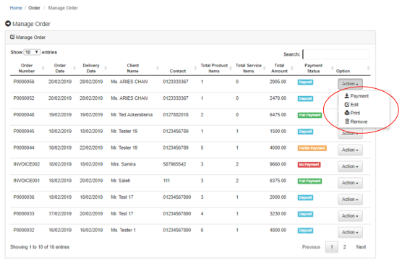

* Print – Change to “View/Print”
* Email - Add’ ‘Email’, user can email Invoice to customer. Pop up message to verify the email address after press “Email”. If email correct, then “Send”. If wrong, then allow “Edit”.

**(b) New Invoice:**

* Order number should not keep running every time refresh.
* 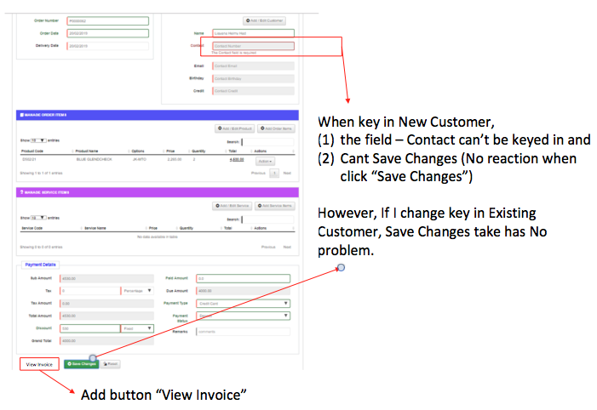 **-** Add button “View Invoice” beside “Save Changes”
* When key in New Customer:
* Input field “Contact” cannot keyed in
* Click “Save Changes” button has no reaction. (noted only allow to Save Changes if keyed in Existing Customer)

**-** Manage Order Items & Manage Service Items

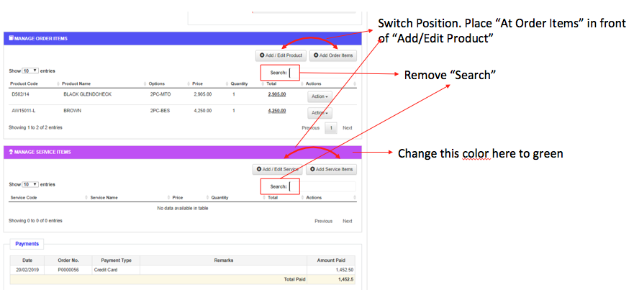

* Switch Position. Place “At Order Items” in front of “Add/Edit Product”,and Place “At Service Items” in front of “Add/Edit Service”.
* Remove “Search”
* Change “Manage Service Items” bar color from purple to green

**(c) Add/Edit Order Items**

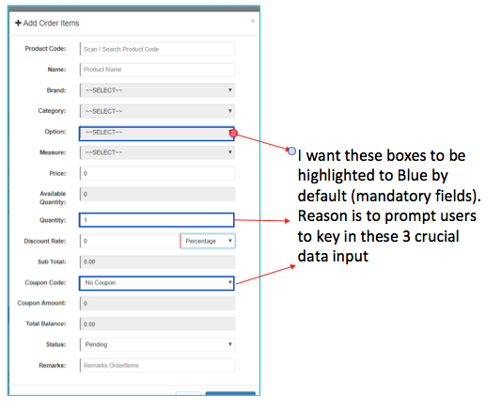

- 3 crucial input fields to be highlighted in color BLUE by default (mandatory fields).

* Options
* Quantity
* Coupon Code
* Order Product that entitled for point collection, but point not added to customer.
* Should not allowed to take order for product with status “Not Available”.
* Should not allowed to take order for product with 0 available quantity. If quantity left 1, order of 2 items or more should be rejected.
* Should update product status to “Not Available” once last product taken and available product quantity should become become 0.

- Status and Date - Orders item & Service Item

* Add Order Item : Currently only have input for Status (Collected, pending), should add “Status Date” field.
* Add Service Item : Need input fields for Status (Ready, Fitting, Delivered, pending) & Status Date.

**(d) Payment Details:**

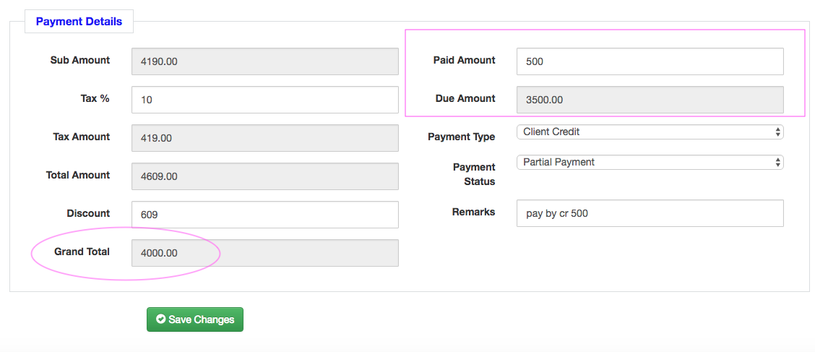

* After “Total Amount” should have “Coupon” field to cater for Coupon for overall discount, for example for Birthday etc.
* Input of coupon for Birthday, system should check against customer birthday month.
* Customer client credit only 500, but system allow to pay by Client Credit more than 500, system Should check whether sufficient credit to use.
* Client credit used not deducted from customer accordingly.
* If order was removed, should add client credit back to customer.

1. **Order Removed**

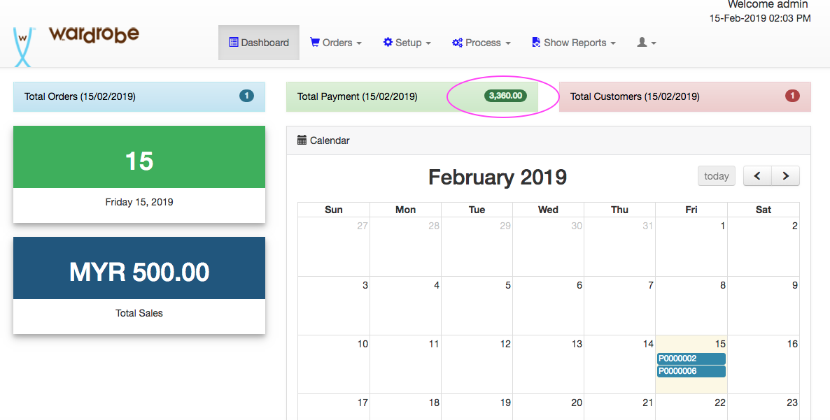

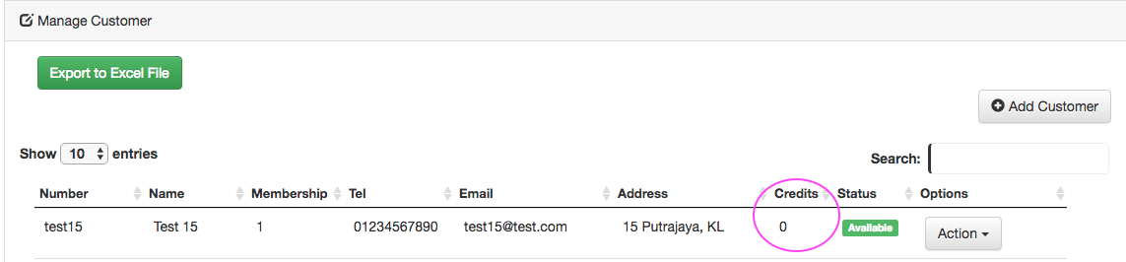

When order was removed, all related items payments, client credit used and product

points given should be reversed and adjusted accordingly:

* Total payment shown in dashboard shluld adjusted accordingly,
* Payment List should show those payments of order being removed,
* Customer Client Credit used (if any) shlould refunded to customer,
* Product points (if that product entitled for points collection) collected by customer should remove from customer.

*Note: As per Spec:*

* *Sales Order is allowed for cancellation / return, refund and exchange (e.g. After making an order with deposits paid, the customer may cancel it and ask for return of deposits)*
* *Item return, exchange and refund (if full payment received)*

1. *Create new sales order (different doc. No) and cancel the previous sales order*
2. *Able to “create new” sales order by copying the cancelled sales order for fast data entry process*
3. *Cancel sales order is required to input reason(s)/ remark(s)*
4. *The new sales order should be able to refer from which previous cancelled  sales order.*

* *item return, exchange and refund (if partial payment received)*

1. *able to edit the sales order*

* *item replacement (either partial or full payment received)*

1. *Create a function called replacement on UI*
2. *Create new sales (different doc no) without cancel the previous sales*
3. *Abe to “create new” sales order by copying the related sales order for fast  data entry process*
4. *Authorization is compulsory by manager level*
5. *Replacement sales order is required to input reason(s) / remark*
6. *The new sales order should be able to refer from which previous related sales  order*
7. *The amount of replacement sales order should be zero “0”*
8. *Replacement report is required on half yearly basis (ref to below report  listing)*

* *Sales orders can be combined when found out they are belonged to the same customer*

**4. Customer**

**(a) Customer - Add/Edit**

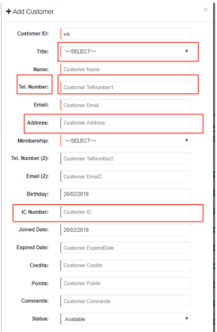

* Title - Dropdown list should show full list. To allow user to self maintain the list.
* Tel. Number – Change to “Mobile Number”, add note (E.g. 0060161234567) below the mobile number input box.
* Address - Replace 1 line input field to as follows:
* Address line 1
* Address line 2
* Postcode
* State
* Country
* Company Name
* IC Number – to remove.

**(b) Order History**

To allow sales person to click shortcut link to view customer Order History on special request to take note.

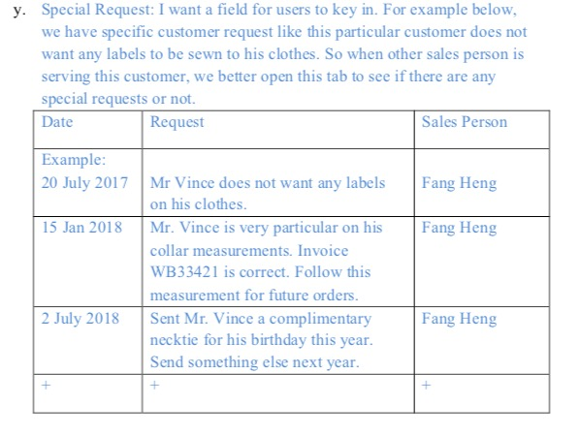

**5. Dashboard**

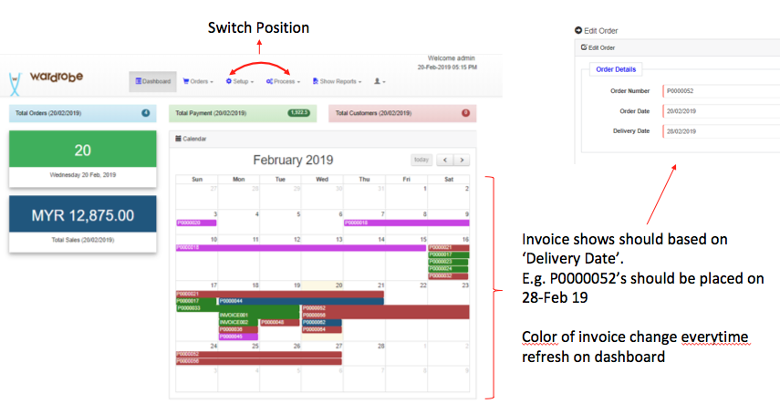

* Switch position on menu items “Process” then “Setup”
* Currently Calender highlighted invoices started from order date to one day before the “Delivery Date” and colors was changed everytime dashboard refresh. Invoice should only shown on “Delivery Date”, and it is okay to have different colors for different invoice but should not changed color everytime dashboard refresh.
* Total sales – should allow to click link to navigate to Manage Order page, and auto filter by today date.
* Total Order - click link to navigate to Manage Order page, and auto filter by today date.
* Total payment - click link to navigate to Payment List page, and auto filter by today date.
* Total customer - click link to navigate to Customer page, and auto filter by today date
* To add field “Status” for total ordered product / services for today and click link to
* navigate to Ordered Products page.

i.e. Total for each status. Currently we don’t have any report or listing yet.. so

system should able to show all status by different date or filter. For example:

* Order Item Status: Collected, pending. (show Status for Collected how many? Pending how many ?) and,
* Service Item Status: Ready, Fitting, Delivered, pending. (show Status Ready how many? Fitting how many ? etc..)

**6. Control payment based on status**

Set the conditions as payment must be made based on what have been collected.

-> Explanation: Item must be paid before or upon collection.

For eg. An order has a shirt cost rm500 and a vest cost rm300. If the customer collects

the vest then the payment collected must be at least rm300.

i.e. To control on how much needs to be collected upon items delivered out.

*Note: As per Spec:*

*- Partial Delivery and Multiple Deposits*

* 1. *(a) Deposit is required for each sales order and delivery. This is to ensure that the sales amount for the items delivered is fully settled and deposit is required for the outstanding items to be delivered. In such scenario, there may have few partial deliveries and multiple deposits at the different time and date in one sales order.*
  2. *(b) Require to indicate “Delivered or delivery date” for those delivered items in one sales order.*
  3. *(c) Able to recall back the sales order and select the item for status update (dropdown list) as*
  4. *ready, 1st fitting, 2nd fitting, 3rd fitting & delivered.*
  5. *(d) Express delivery will have additional charges (additional charge for e.g. 1day $300, 3 days $150, 5 days $100)*