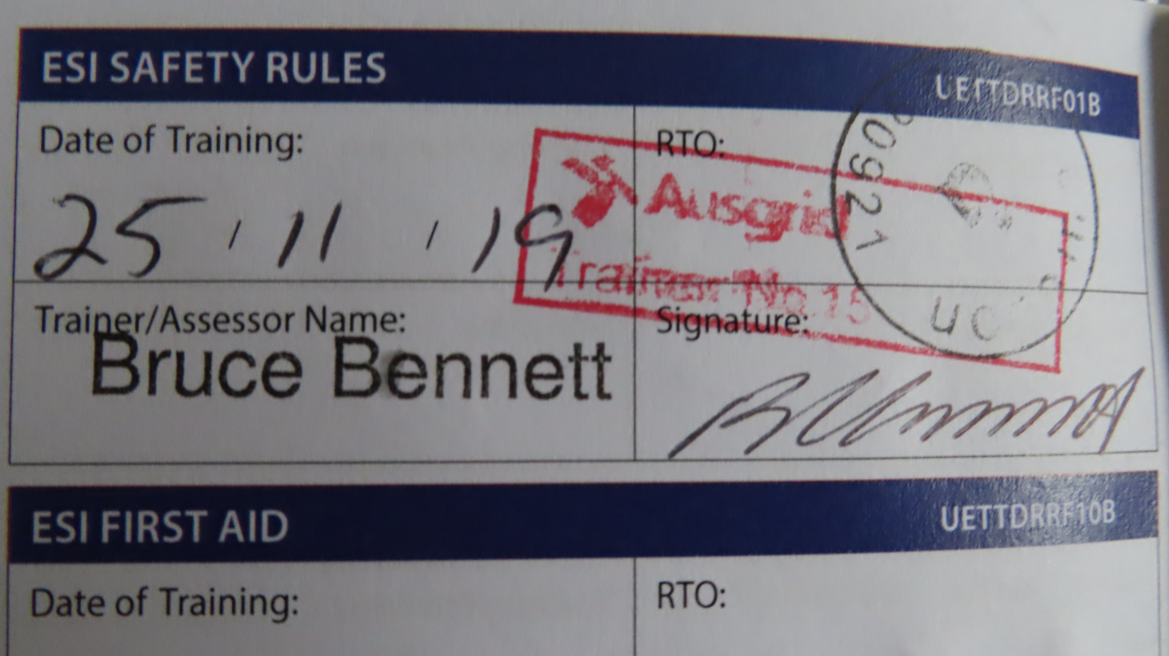

**Resume of PETER DUFFY**

To whom it may concern,

I have been employed in the electrical distribution industry for 38 years, this employ was with commenced with Sydney County Council and finished with Ausgrid in 2015.Whilst working for Ausgrid I was employed as an Underground Cable Jointer and as a Regulatory Trainer for the last 10 years of my tenure with the organisation.

Over the past 3 years I have been employed by Combined Training and Consulting Safety as a trainer of various courses that are a pre-requesite for employees in the electrical industry. Below is a list of the units of competency and relevant qualifications that I presently hold.

|  |  |  |
| --- | --- | --- |
| **Unit / Cert No.** | **Title of unit** | **Issuing Organisation** |
| TSR 36179 | Trade Skills Recognition | NSW Dept. of Industry |
| TAE 40116 | Cert iv Training & Assessment | TAE Institute |
| UETTDREL14A | Work safely near live electrical apparatus as a non electrical worker | CTC Safety |
| UETTDRRF02B | Perform Pole – Top Rescue | CTC Safety |
| UETTDRRF03B | Perforn EWP Rescue | CTC Safety |
| UETTDRRF06B | Perforn rescue from a live LV panel | CTC Safety |
| UETTDRRF08B | Perform EWP controlled descent escape | CTC Safety |
| UETTDRRF10B | Provide 1st aid in an ESI environment | CTC Safety |
| HLTAID001 | Provide cardiopulmonary resuscitation | CTC Safety |
| RIIWHS204D | Work safely at heights | CTC Safety |
| FAM0061 | Endevour Energy Excavation Procedures | CTC Safety |
| UETTDRRF01B  UETTDRRF09B | ESI Safety Rules  Network Access Procedures  Environmental | Ausgrid  Issued 25/11/19 at  Ausgrid Wallsend  Ausgrid |

I hope this information is adequate, if any elaboration on the foregoing information is required, please contact me personally.

Regards,

Peter Duffy Ph. 0419 630 995