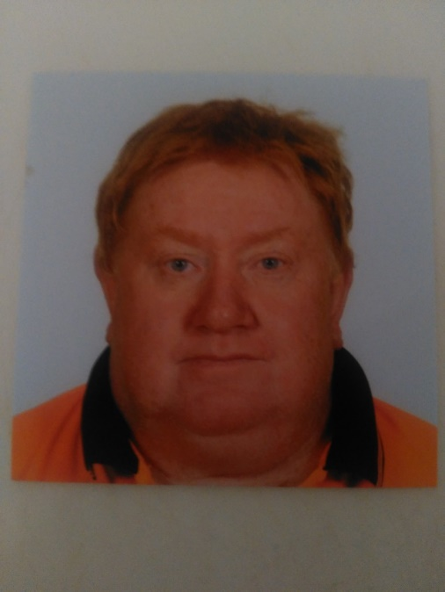

RESUME

Richard Benson

Experienced Electrical Tradesman

# Career background

35 years + continuous employment within Electrical Industry

Broad knowledge of electrical infrastructure projects and scope of works

Electrical contractors’ licence 34344 Q

WorkCover White- Card - CG100808629SEQ1

Crane Chaser Licence No. CH 28476

Forklift Licence HR803160

)

“A” Grade Electrical Mechanic Licence

Certificate III in Transport and Distribution

Certification in Safe Working Practices for Access Permit Issuers

## Profile

Suitability for the role:

I have over 30 years’ experience within various with roles for the in greater western Sydney and various sub contract roles as -

- Electrical fitter 1986 to 1999 (Prospect County Council) (Prospect Electricity) (Integral Energy)

- Emergency services officer 1999 to 2005 (Integral Energy)

- District operator 2005 to 2015 (Endeavour Energy)

- Contract Inspector Subcontract 2016 to 2016 (Endeavour Energy) for (Australian Power & Data)

- Contract Meter Tech Subcontract 2016 to 2018 (O’Donnell Griffin)

- Contract Courier Subcontract 2018 to 2018 (Blu Couriers)

- Delivery Driver Casual 2018 to 2019 KRE (Metal and More)

- Auto Door Tech 2019 to Present (ASSA Abloy)

* Focused on working cooperatively and effectively within a diverse team
* Highly versatile, well suited to the challenges and responsibilities for a productive outcome
* Completes assigned work activities with a focus on achieving quality work standards, and project schedules and specification standards
* Proactive in promoting and maintaining a safe workplace including: sound Occupational Health and Safety (OHS) knowledge and Workplace Health and Safety (WHS) practices

Key responsibilities include:

* Project management of a wide variety of major projects across the network
* Ability to problem solve and deliver solutions as required
* Assisted with significant Electrical Network events – handle the entire rollout process to completion

### Tickets and Certifications

Workshops and Certificates:

2020 HC Driver licence upgrade 7178AS

2017 Forklift drivers licence HR 803160  
2014 Apply Fatigue Management Strategies – TLIF2010A – Cobra Training Services

2005 Plan Assessment ~ Conduct Assessment and Review Assessment – Pollak Learning Alliance

2002 Customer Service ~ Integral Energy

2001 Safe Working Practices for Access Permit Issuers – Integral Energy

2001 Certificate III in Transport and Distribution (Road Transport) - TAFE New South Wales

2000 Certificate II in Transport and Distribution (Road Transport) – TAFE New South Wales

2000 Certificate in Confined Space Entry – Integral Energy

1995 Train the Trainer – On the Job – Prospect Electricity Training Services

1986 A Grade Electrical Fitter Mechanic’s Licence – Energy Authority of New South Wales

Merits and Awards:

1994 Merit Award - Exceptional Work-Related Performance - Prospect Electricity

1992 Awarded TEAM MEMBER - Prospect Electricity Quality Improvement Process

Tickets - Licences:

Current Forklift Drivers Licence HR 803160

Current OHS Certification Australia WP WK Flat Boom Over 11 Metres N-0041945/1

|  |  |  |
| --- | --- | --- |
| Current |  | OHS General Induction for Construction Work in NSW - WorkCover Card - CG100808629SEQ1 |
| Current |  | Crane Operator Licence No. CH 28476 |
|  |  |  |
| Current |  | HC drivers licence 7178 |
|  |  |  |
| Current |  | OHS Certification Australia - WorkCover |
|  |  |  |

## Regards

Richard Benson

H / 02 45775206

M/ 0490 123 203

Email – rpbenson66@gmail.com

|  |  |
| --- | --- |
|  |  |
|  |  |
|  |  |
|  |  |
|  |  |
|  |  |
|  |  |

Available for Immediate Placement