1) We need to remove “ONLY_FULL_GROU_BY”. Because group by queries are not working.
Please check below image

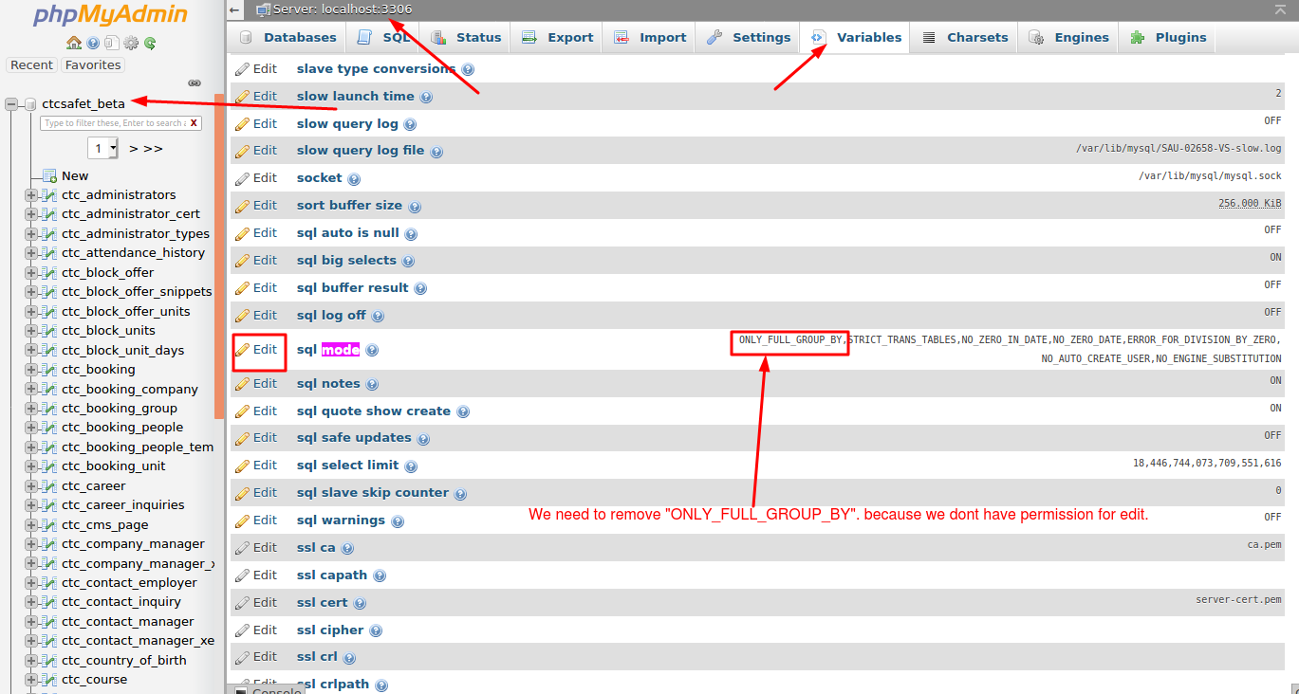

2) We have created one new email account (support@ctcsafety.com.au). But we are not able to check mail over there. We are getting message on new tab that “Unable to connect”. Can you please check for us as we need SMTP credentials for sending emails. Check image below.

