SITE CARD

1. New member is not showing in the table even after submitting.

<http://dev6.wethedevelopers.com/MatthewYoung/Sitecard/final/siteadmin/manage_members.php>

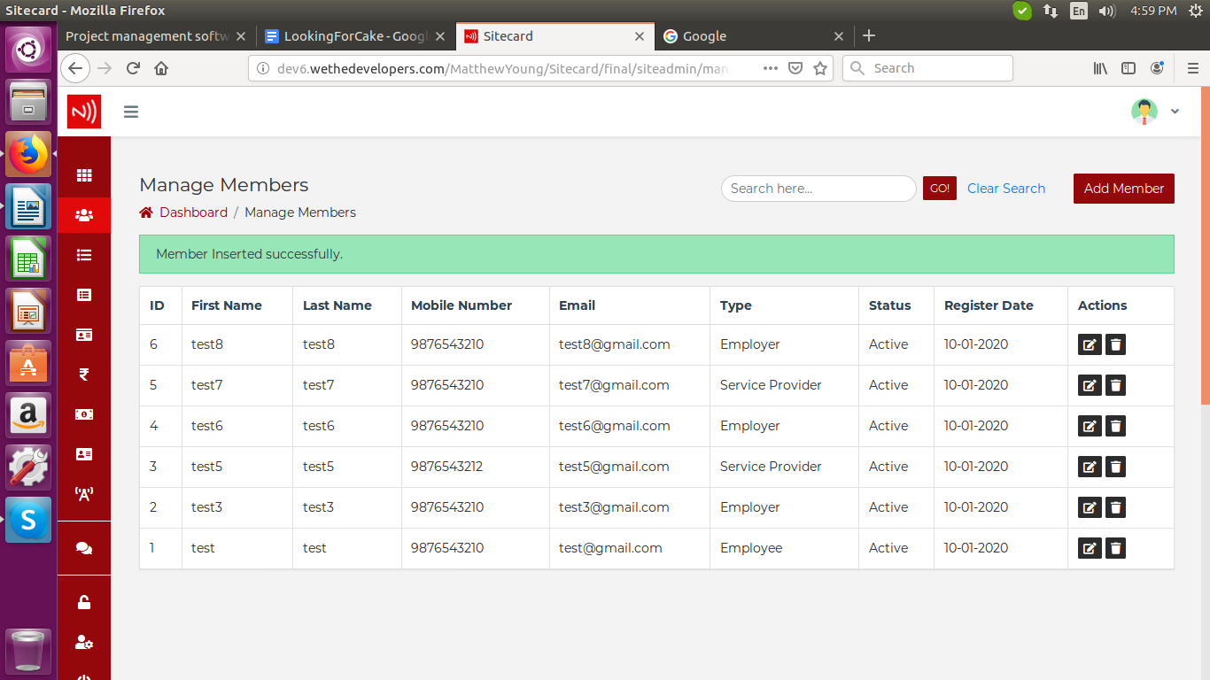

2. In alert message, change ‘somthing’ –to--> ‘something’.

<http://dev6.wethedevelopers.com/MatthewYoung/Sitecard/final/siteadmin/add_member.php>

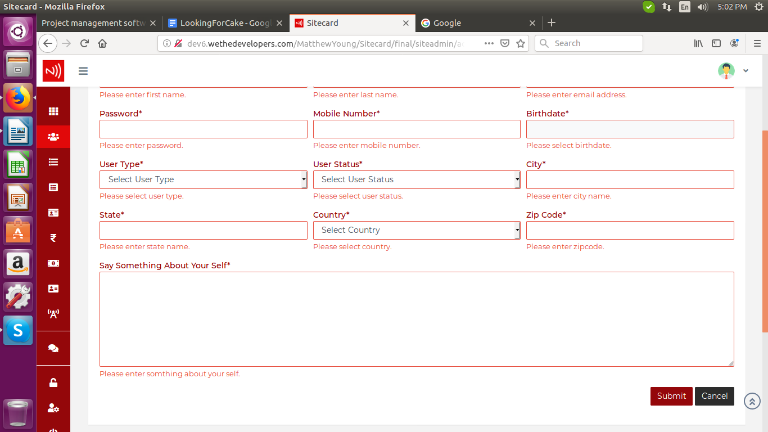

3. Remove ‘\*’ sign from non-mandatory fields.

<http://dev6.wethedevelopers.com/MatthewYoung/Sitecard/final/siteadmin/add_cms.php>

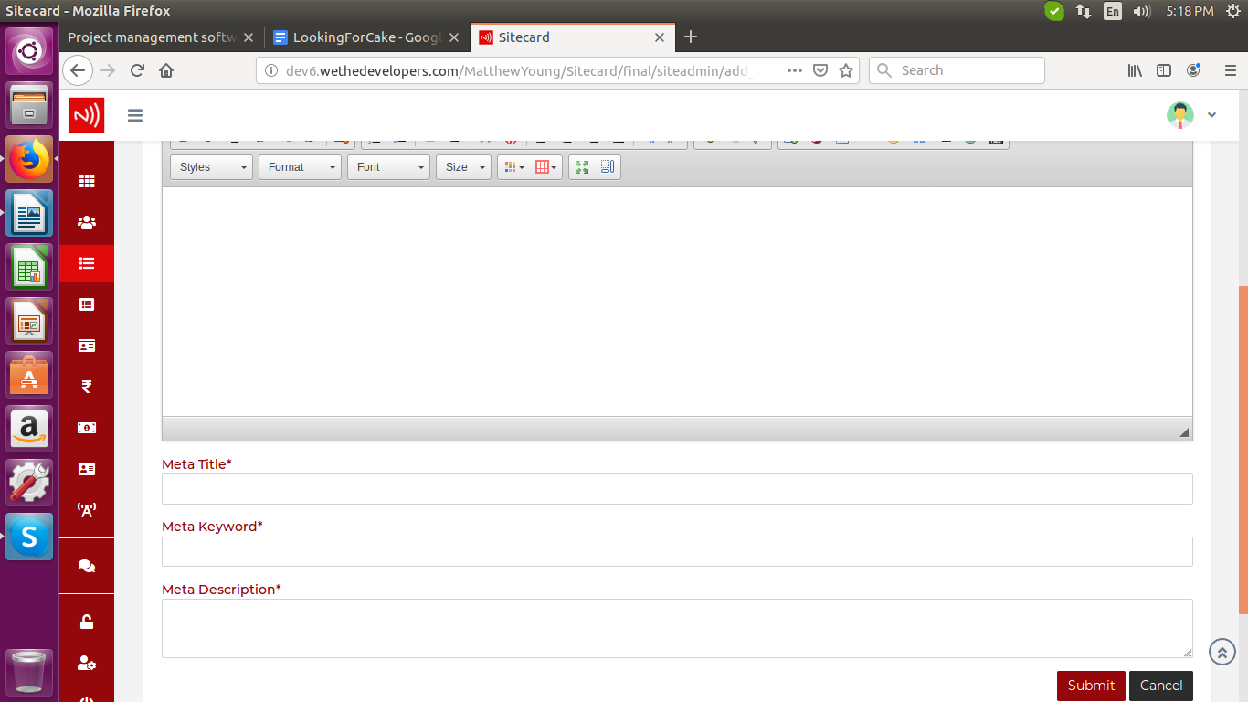

4. On deleting Subscription plan, it is not getting delete.

<http://dev6.wethedevelopers.com/MatthewYoung/Sitecard/final/siteadmin/manage_subscription_plan.php>

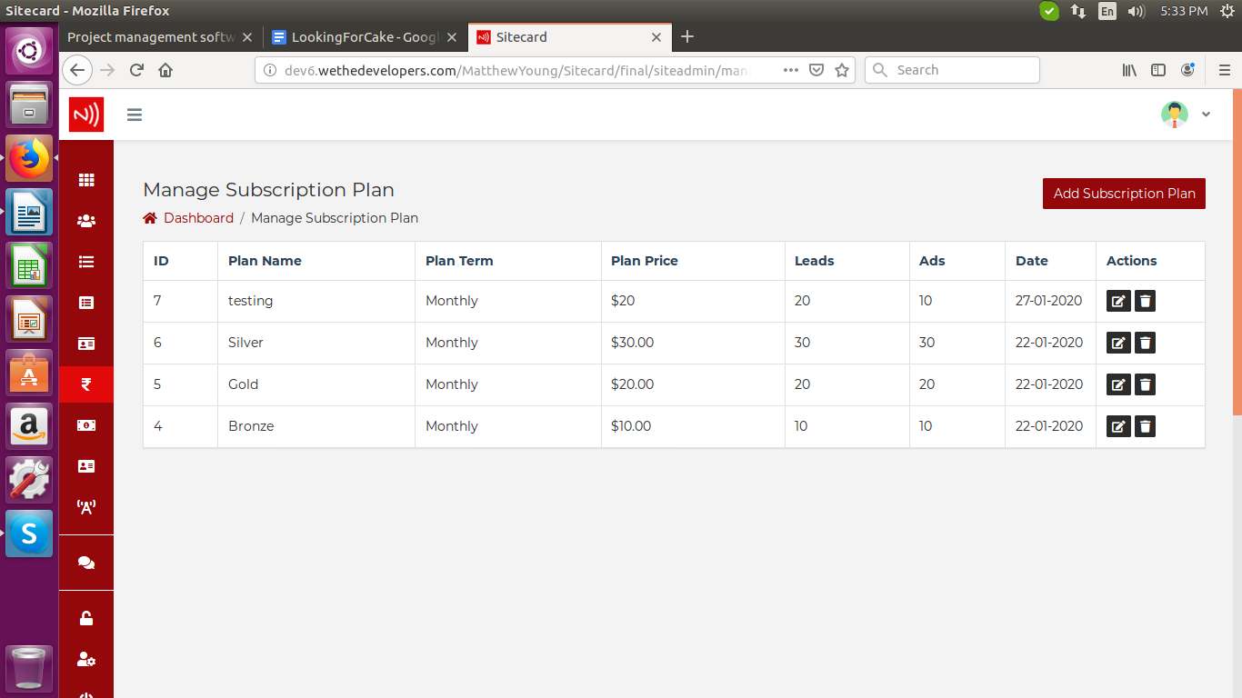

5. Change “Inquery” --to--> “Inquiry” in the ‘Contact Inquery Not Found.’ message.

<http://dev6.wethedevelopers.com/MatthewYoung/Sitecard/final/siteadmin/manage_contactus.php>

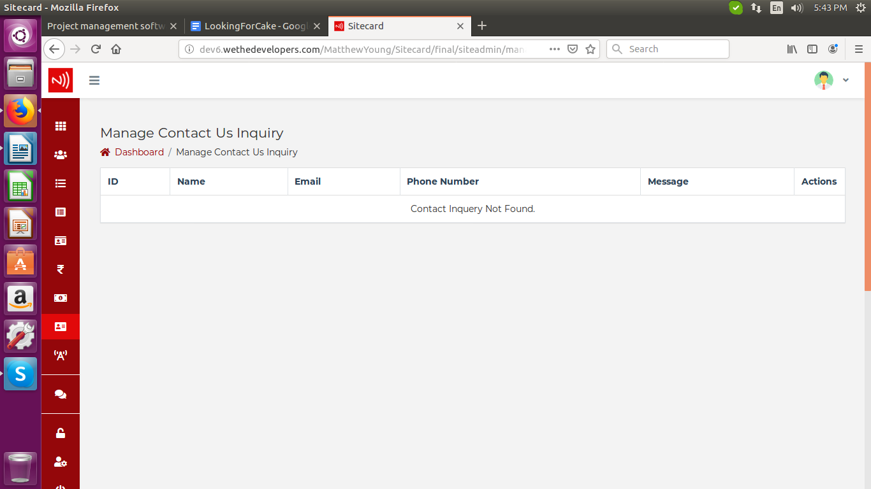

6. Change this Footer.

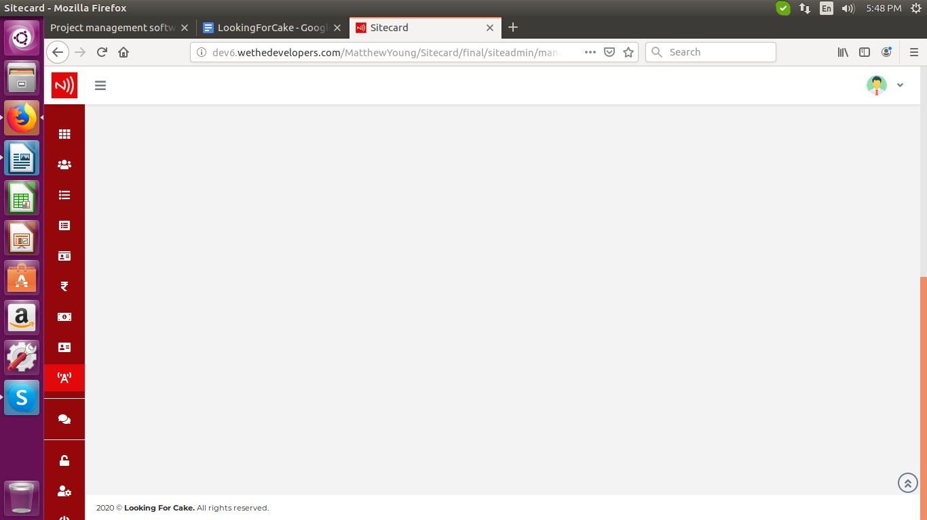

7. On submitting it is directing to this page.

<http://dev6.wethedevelopers.com/MatthewYoung/Sitecard/final/siteadmin/add_broadcast.php>

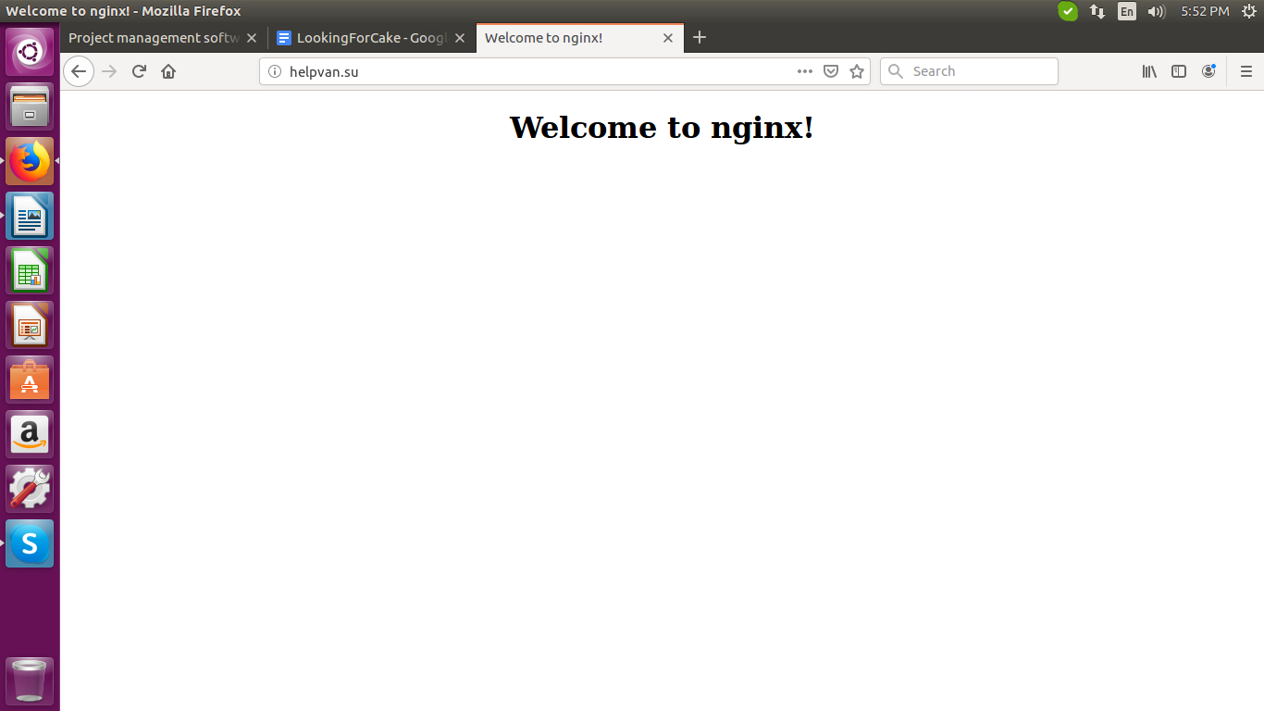

8. For Select Members, Change alert message from “Enter Group Name” --to--> “Select Members”

<http://dev6.wethedevelopers.com/MatthewYoung/Sitecard/final/siteadmin/add_group.php>

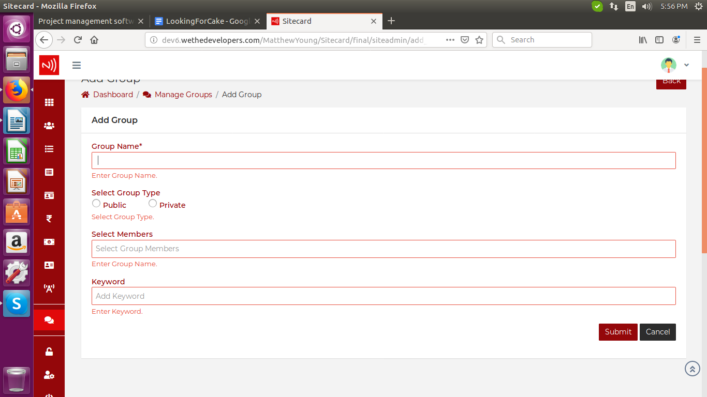

9. Remove this warning.

<http://dev7.wethedevelopers.com/matthewyoung/sitecard/final/profile-friend-list.php>

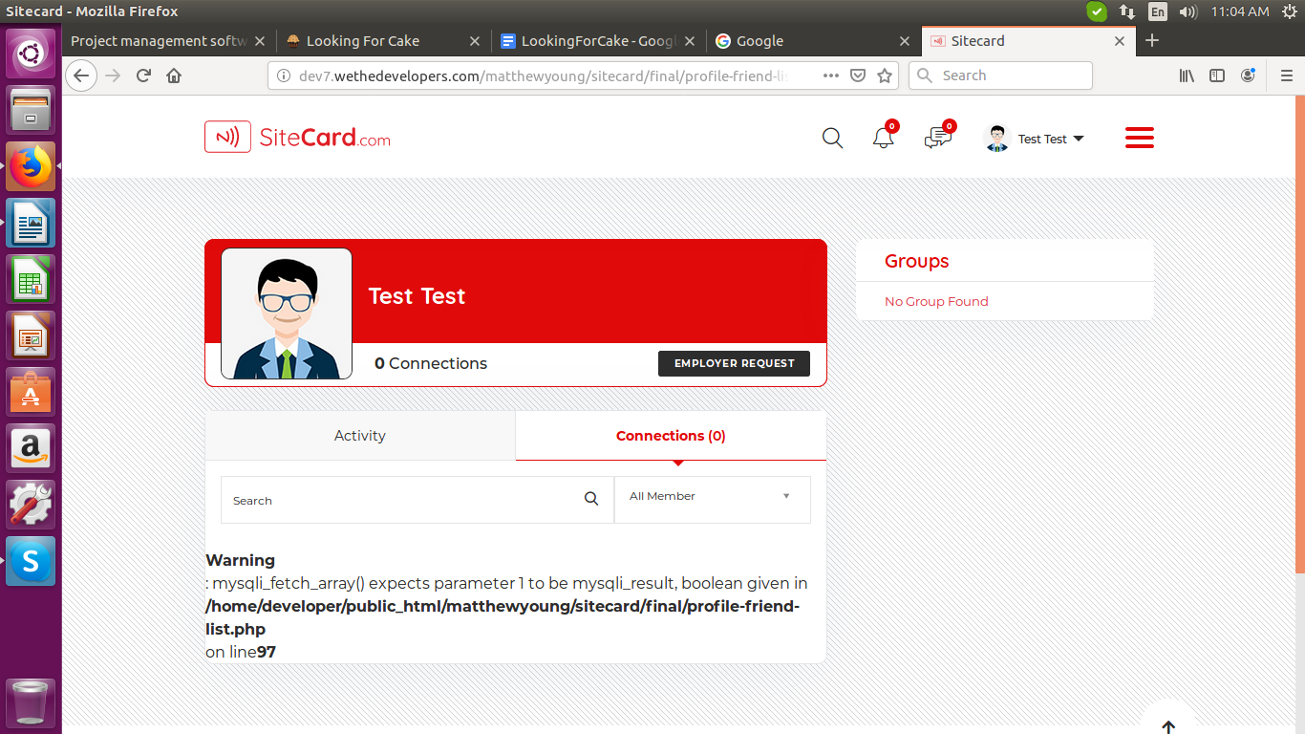

10. Design all the dropdown similar to text box so the selected text in dropdown comes in the center like other text box.

<http://dev7.wethedevelopers.com/matthewyoung/sitecard/final/profile-edit.php>

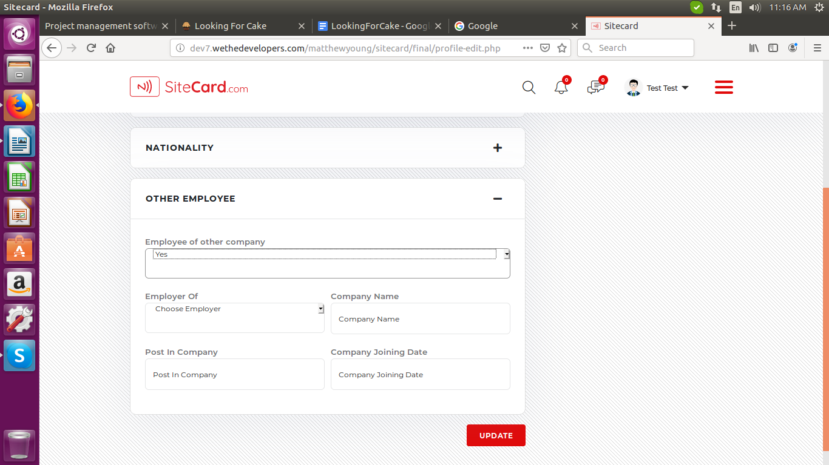

11. ‘Delete Post’ option is not working.

<http://dev7.wethedevelopers.com/matthewyoung/sitecard/final/wall.php>

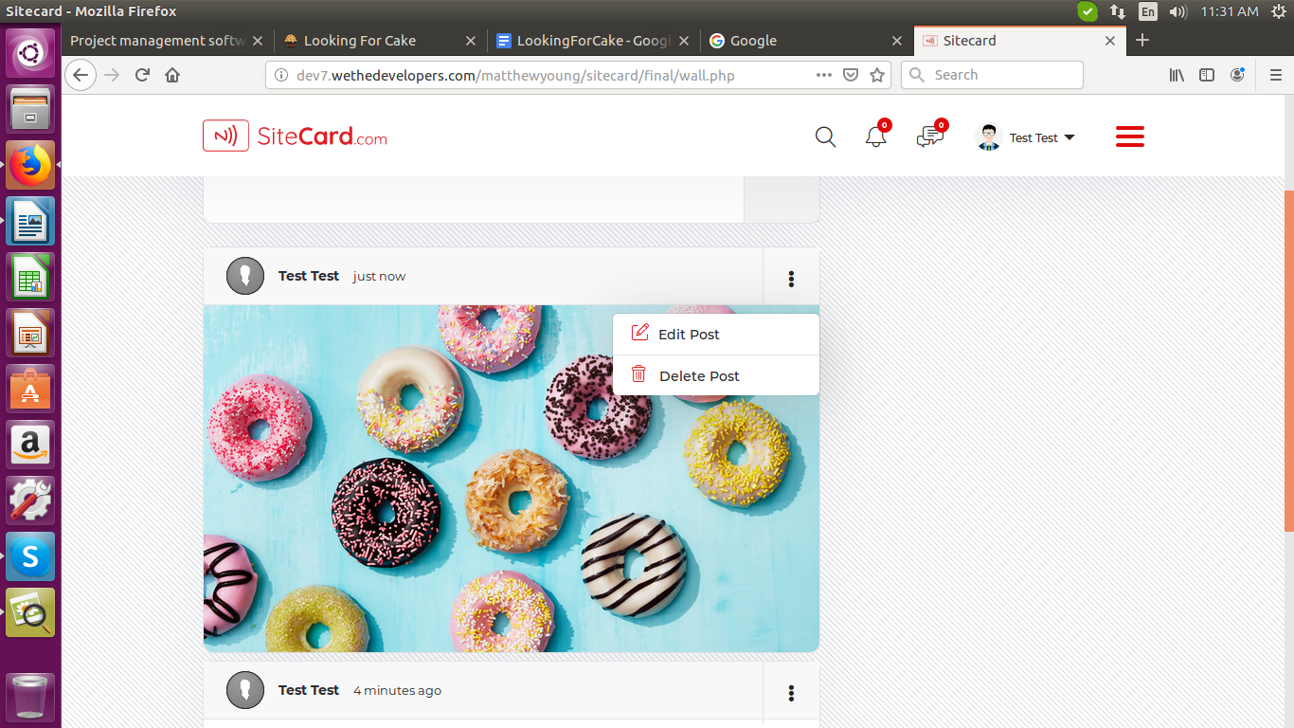

12. Member details are not getting updated, for employer.

<http://dev7.wethedevelopers.com/matthewyoung/sitecard/final/siteadmin/manage_members.php>

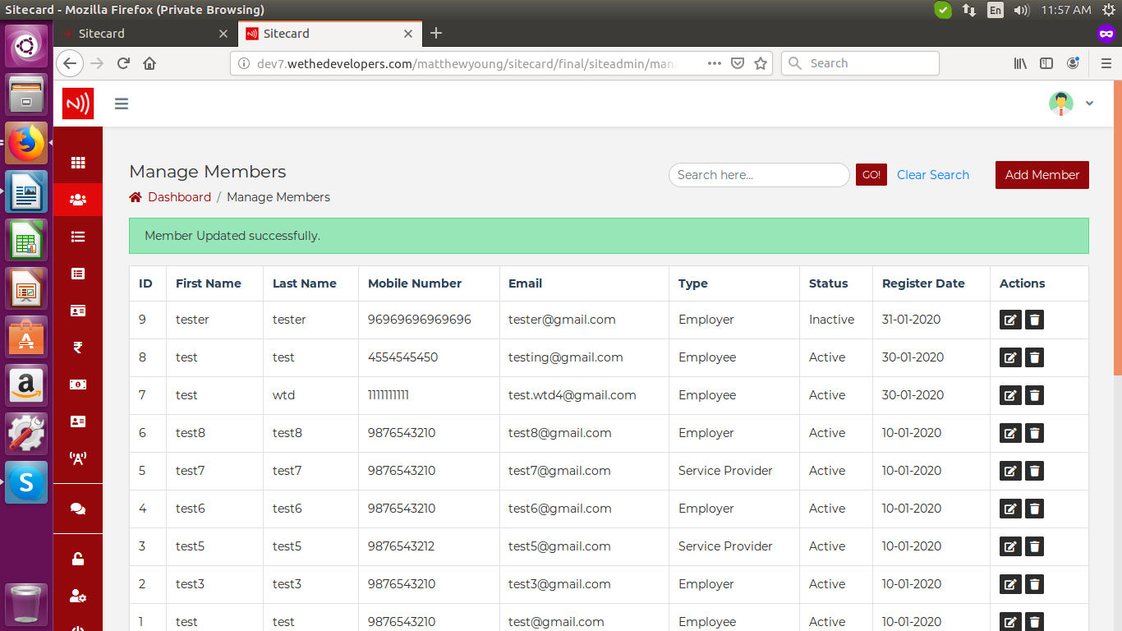

13. Change the default date for ‘birthdate’ and ‘Company Establish Date’. It is not showing the birthdate entered by user during sign up. It is taking random ‘birthdate’ for all members.

<http://dev7.wethedevelopers.com/matthewyoung/sitecard/final/siteadmin/edit_member.php?id=OQ==>

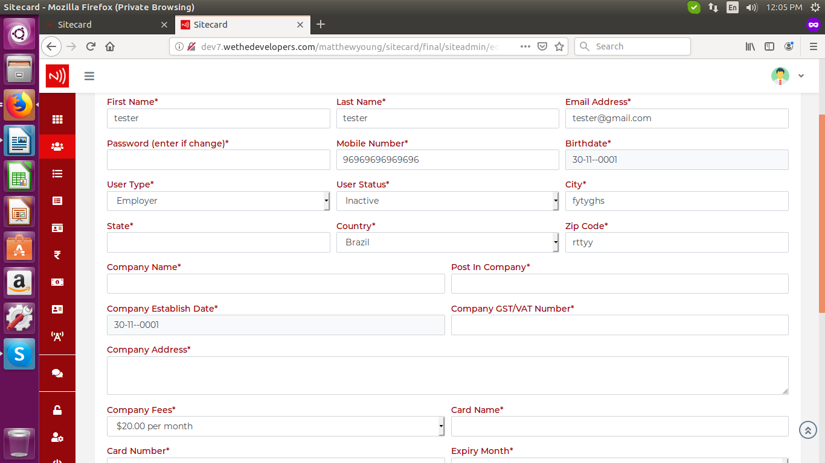



14. remove the errors which it is showing.

<http://dev7.wethedevelopers.com/matthewyoung/sitecard/final/siteadmin/manage_broadcast.php>

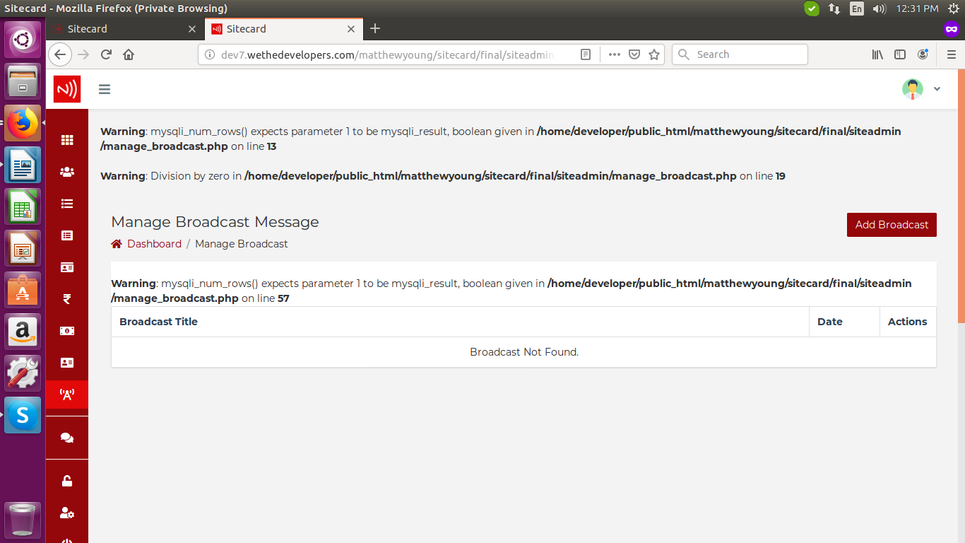

15.