**Confusion Apixall**

**1) Here multiple schedule is assign to employee**

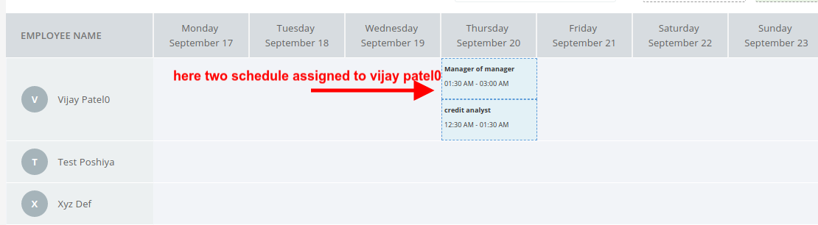

now when employer is visit view payroll page at that time we are displaying per day earning calculation right?

So my question is how can we manage multiple schedule here?

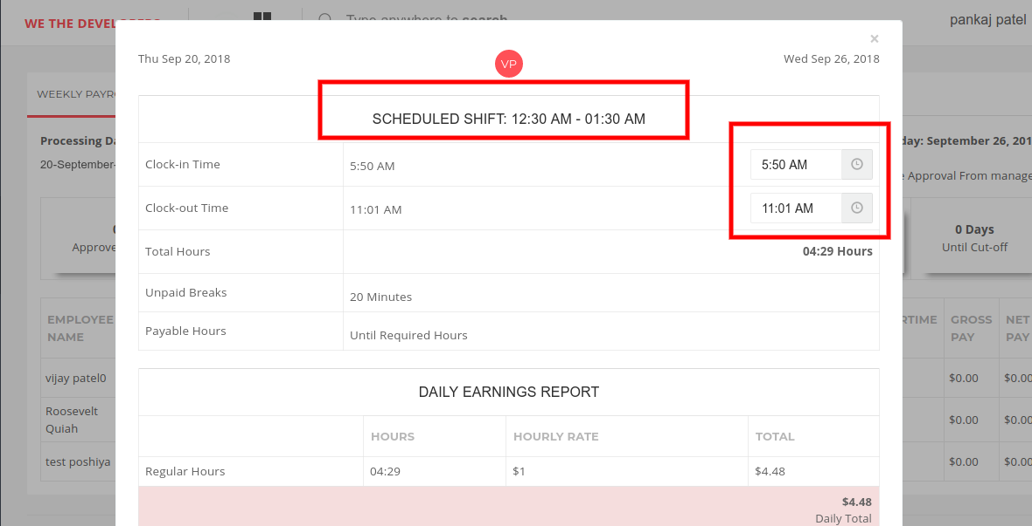

Here we cannot display multiple schedule information we can display single schedule shift   
can you please suggest what shoud we do here?

**2) Overtime pay rate confusion**

any employer can create shift for example

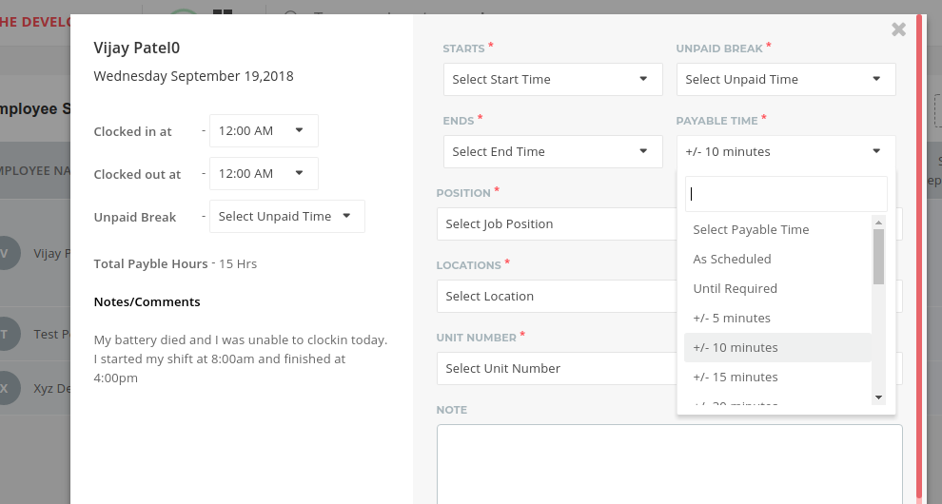

and select payable time plus or munus 10 minutes for monday,tuesday,wednesday,thursday,frieday  
  
**plus or minus 10 minutes means: employer will not pay after 10 minutes of overtime**

now at the time of salary calculation we are getting below issue

**DailyOvertime Daily Double time**

**Sunday 0Hr 0 0**

**Monday 8Hr 0 0**

**Tuesday 10Hr 2 0**

**Wednesday 12Hr 4 0**

**Thursday 14Hr 4 2**

**Frieday 13Hr 4 1**

**Saturday 6Hr 0 0**

**So daily overtime is 14 Hr**

**weekly overtime is 63-40=23**

**Double time is: 3**

**as per our schedule employer will pay only 10 min of overtime a day**

**employee is able for overtime in monday,tuesday,wednesday and thursday**

**total work day =4*10(minutes)= 40 min   
  
Now 40 min should consider in regular overtime or double time?**