**General**

1. Publish to web is not working.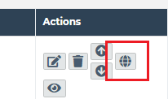
2. Apply some other background color to Archived or inactive rows. **Design**
3. save both images i.e. big image and cropped image
4. Add validation for existing email ids
5. Set minimum length for passwords
6. add facility of remove document for document -> does not work
7. add “$” sign in price or rate fields

<http://dev6.wethedevelopers.com/MatthewYoung/final/siteadmin/add_gallery_category.php>

1. Please remove ‘Category Order’ field (Add/Edit)

<http://dev6.wethedevelopers.com/MatthewYoung/final/siteadmin/add_gallery.php>

1. Remove ‘*’ from ‘Gallery Course’

**Manage Contact manager**

<http://dev6.wethedevelopers.com/MatthewYoung/final/siteadmin/manage_contact_manager.php>

1. When new contact manager is created, CLIENT STATUS shows ACTIVE, but sign is INACTIVE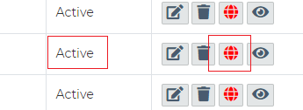

**Manage industry**

<http://dev6.wethedevelopers.com/MatthewYoung/final/siteadmin/add_industries.php>

1. in image once you select image and then “Close” crop pop up and again select image it didn’t open crop pop up.
2. please align this both field vertically. **Design**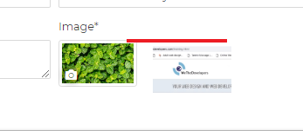

<http://dev6.wethedevelopers.com/MatthewYoung/final/siteadmin/add_training_unit.php>

1. remove down arrow in “Manage Pre requisite”.-not done in Edit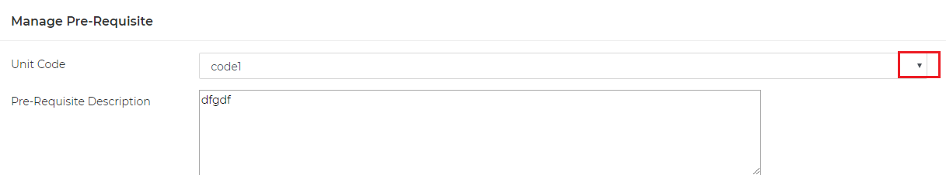

<http://dev6.wethedevelopers.com/MatthewYoung/final/siteadmin/manage_training_unit.php>

1. when you select “include archived units” and moved to other pages it untick”Include archive” selection.

<http://dev6.wethedevelopers.com/MatthewYoung/final/siteadmin/edit_training_unit.php?id=MTg=>

**Manage Unit Group**

<http://dev6.wethedevelopers.com/MatthewYoung/final/siteadmin/add_unit_group.php>

1. There should be one unit in group.

<http://dev6.wethedevelopers.com/MatthewYoung/final/siteadmin/edit_unit_group.php?id=MTM=>

1. when you remove any unit from unit group ,it is not added to build unit group dropdown.
2. when you remove any unit from unit group please add alert before removing. -> done but change alert message to ‘Are you sure you want to delete this Unit ?’

**Manage Mode of Delivery**

**Manage Trainer**

<http://dev6.wethedevelopers.com/MatthewYoung/final/siteadmin/add_trainer.php>

1. New trainer does not show up after adding

**Manage location**

<http://dev6.wethedevelopers.com/MatthewYoung/final/siteadmin/manage_locations.php>

1. is status is “Archived” it shows “active ” in “View ” pop up.

<http://dev6.wethedevelopers.com/MatthewYoung/final/siteadmin/edit_locations.php?id=Mg==>

1. at time of edit add dot in map at selected location
2. change ”Hired venue day rate rate(GST free)” to “Hired venue day rate(GST free)”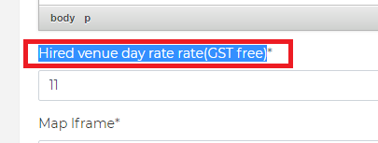

<http://dev6.wethedevelopers.com/MatthewYoung/final/siteadmin/add_locations.php>

1. add error message for “Map/Location” field.
2. add proper error message instead of “This field is required” for “Hired venue day rate rate(GST free)*” and “Maximum Seats Available*” Fields.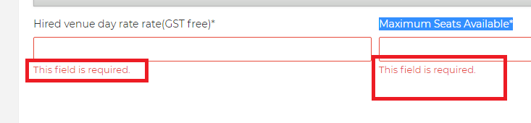

**Manage snippets**

<http://dev6.wethedevelopers.com/MatthewYoung/final/siteadmin/manage_snippest.php>

1. in “View” pop up change “Snippes category” to “Snippets category”
2. please fix this when only one row in table.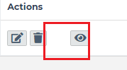**Design**
3. Up down arrow is not working correct.

**Manage Library**

<http://dev6.wethedevelopers.com/MatthewYoung/final/siteadmin/add_library.php>

1. minimum 1 document or link is mandatory in one resource.
2. in “Upload ” section add “Name ” and upload button ,when user enter both and click on “+” provide another name + upload document field
3. “Title” field value should be unique

<http://dev6.wethedevelopers.com/MatthewYoung/final/siteadmin/edit_library.php?id=NQ==>

1. if user change type then remove all listed links or document below.
2. heading should be either “Manage links” or “Manage Document”.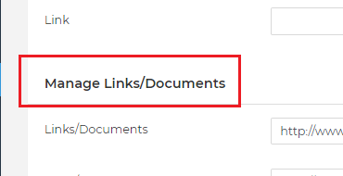

<http://dev6.wethedevelopers.com/MatthewYoung/final/siteadmin/manage_library.php>

1. “Order ” is not working properly

**Manage home banner**

<http://dev6.wethedevelopers.com/MatthewYoung/final/siteadmin/manage_homebanner.php>

1. Up down arrow is not working correct.

**Contact Manager**

<http://dev6.wethedevelopers.com/MatthewYoung/final/siteadmin/add_contact_manager.php>

1. add text box for “other ,specify” option in “Employment Status”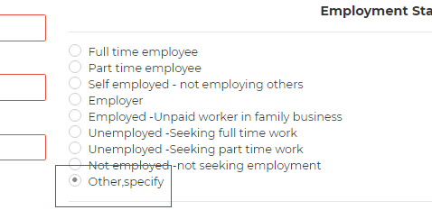
2. add error messages for “Email” and “Recovery Email”.
3. add error message if “yes ” is selected in “Disability” and no one selected in “Area of Disability”

**Company Manager**

<http://dev6.wethedevelopers.com/MatthewYoung/final/siteadmin/add_company_manager.php>

1. “Admin Email “ field is missing.
2. add space between HR and Dropdown.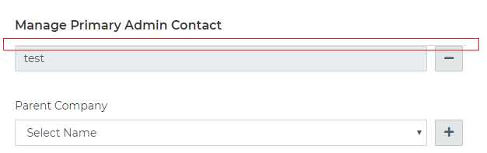
3. Division,select title,First name.last name, DOB ,company email,password,recovery email,username, ABN,ACN, business website, Business mobile ,business mobile,division is mandatory fields
4. in “Sales Contact” dropdown display sales member from administrator module.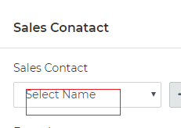
5. in “Sales Contact” ->From where ”Sales phone” detail came from ,....because there is no such type of field in “Administrator”
6. in “Sales discount general ” and “Sales discount Group” value should not greater than 100
7. when you save company details ,“Sales Contact” details doesn't save
8. add validation for “Sales contact” details
9. allow only digits in “PostCode”
10. remove company division as there is already “Division” field.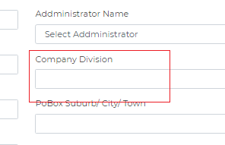
11. Correct spelling ‘Addministratior’ -> ‘Administrator’ and please fix drop down arrow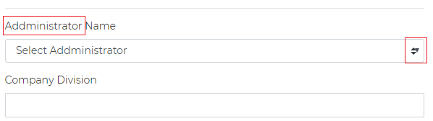
12. there is PO box details 2 times.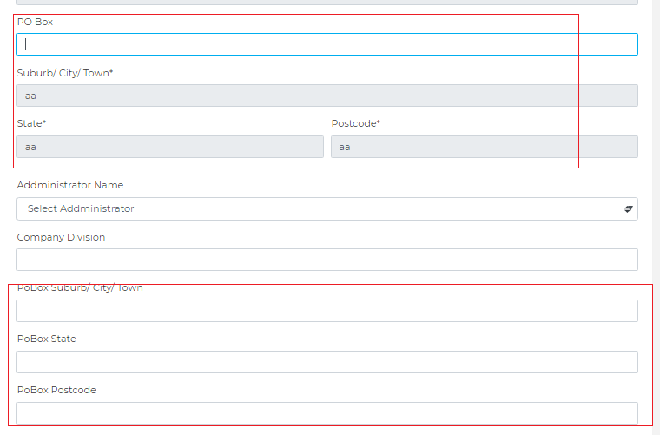

**Manage Our Clients**

**Manage openings**

**Manage Give away Company** <http://dev6.wethedevelopers.com/MatthewYoung/final/siteadmin/add_giveaway.php>

1. product should be compulsory.
2. add error message if product image is not selected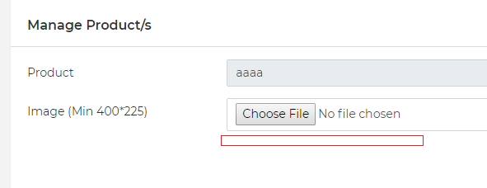

<http://dev6.wethedevelopers.com/MatthewYoung/final/siteadmin/edit_giveaway.php?id=MQ==>

1. add alert when you remove product details from “Manage Product”

**Manage Give away Inventory**

<http://dev6.wethedevelopers.com/MatthewYoung/final/siteadmin/manage_giveawayinventory.php>

1. remove archived company from “Select Company ” dropdown

**Manage Administrator**

<http://dev6.wethedevelopers.com/MatthewYoung/final/siteadmin/add_administrator.php>

1. “Network Permission” and “Send User Invitation” is missing.
2. in “Document” section , there should be three field Document name, expiry date and Upload document together and when user click on “+” button these 3 field should replicate.
3. remove space before error message. **Design**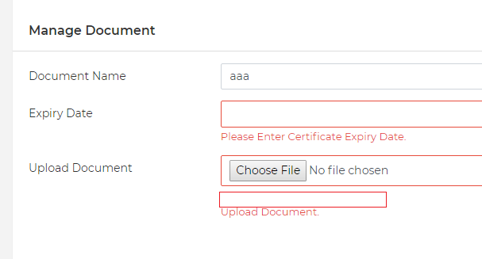
4. display one message.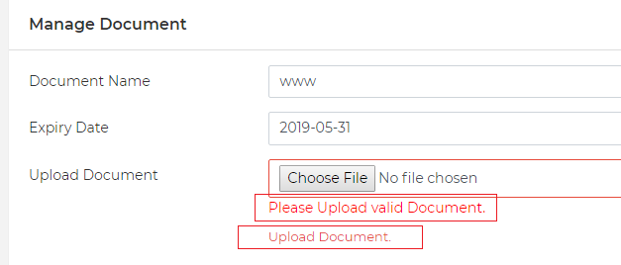
5. please only allow digits in mobile number fields

<http://dev6.wethedevelopers.com/MatthewYoung/final/siteadmin/edit_administrator.php?id=Mg==>

1. for one user “Document name” should be unique
2. add error message for document name.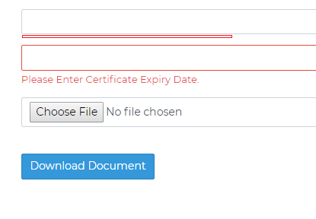
3. it allow to save details even if Document is not selected.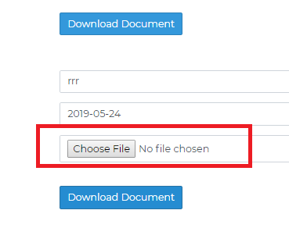

**Manage Unit block**

[**http://dev6.wethedevelopers.com/MatthewYoung/final/siteadmin/add_unit_block.php**](http://dev6.wethedevelopers.com/MatthewYoung/final/siteadmin/add_unit_block.php)

1. Search functionality is not working
2. Correct spelling -> ‘Business Note’

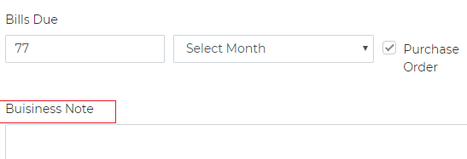

1. blank value in start time ,end time should not allowed.
2. please enter error message or alert if Time or Block group code is blank in any row.
3. Numbering is not proper.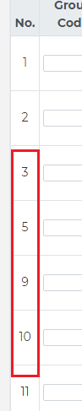
4. one block should not contain same unit twice or more.
5. need to see W% calculation .by default it should display 0
6. please fix “NaN” error.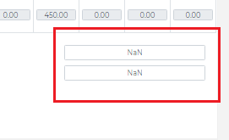

**Manage Block Offer**

<http://dev6.wethedevelopers.com/MatthewYoung/final/siteadmin/edit_unit_block.php?id=MQ==>

1. when erro at least one unit should be selected.

**Manage Trainer**

<http://dev6.wethedevelopers.com/MatthewYoung/final/siteadmin/add_trainer.php>

1. allow only digits in “Mobile no.”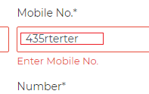
2. Username should be unique
3. if “Trainer is Superviser” option is checked ,add error message for “Select Category”, “Select Industry” and “Select Other Trainer This Trainer Supervises” fields.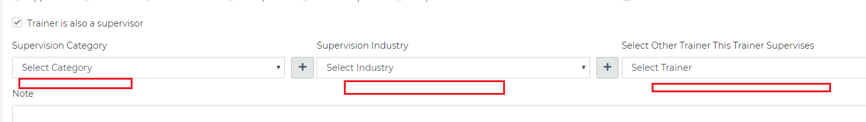
4. make this text bold and bigger.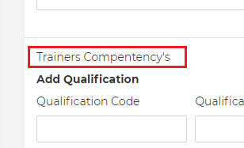
5. Trainers Qualification is compulsory
6. “Current employment contract ” is Heading so make text bold, remove checkbox, all details in it is mandatory and only digit and dot. should allow in “Rate for quoting” field allow.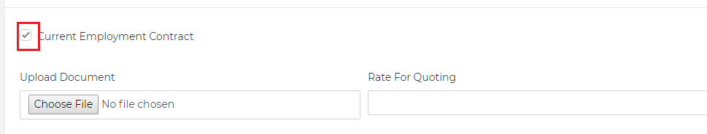

**Testimonials**

<http://dev6.wethedevelopers.com/MatthewYoung/final/siteadmin/manage_testimonail.php>

1. color of “Published to web ” icon should be green or red.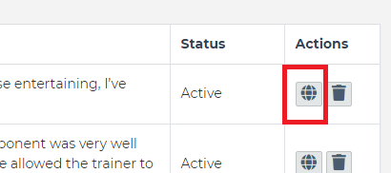

--------------------------------------------------------------------------------------------------------------------------------

**Front-End**

**General**

1. web and mobile view = Whichever tab is open should be selected in menu
2. in footer click in New slider is not working as in design.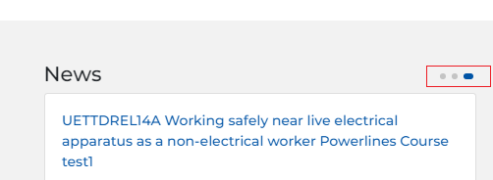
3. mobile view= in footer put one menu text in one line.**Design**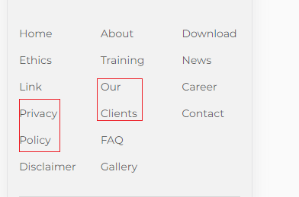
4. responsive = how to close side menu .after scroll?**Design**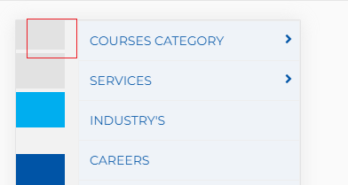’

**Sign-Up pop up**

<http://dev6.wethedevelopers.com/MatthewYoung/final/>

1. in “Title” field remove down arrow in background.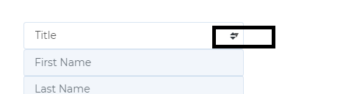
2. remove down arrow in “Date of Birth” field.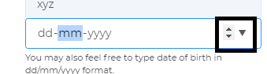
3. put error message after text.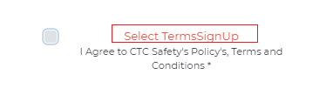
4. change Error message to “Please Accept Terms And conditions”.
5. remove link on “Yes, send me CTC Safety Course Date and Offers” text. -> Please remove the LINK on the text, NOT TEXTS. Please keep texts as it was before  
   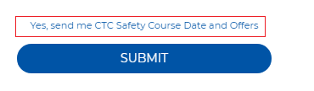
6. when you entered all details and click on “submit” it gives “404 error”.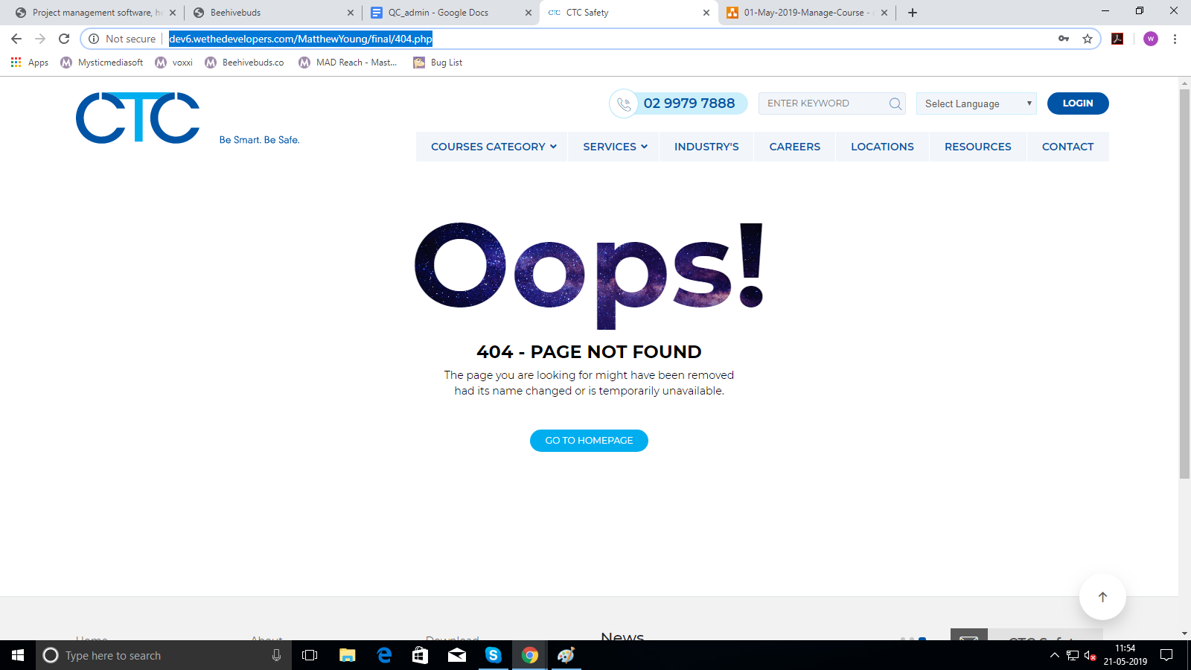
7. discuss “Current company you work for”
8. Organization user ->put error message for Terms and condition after text.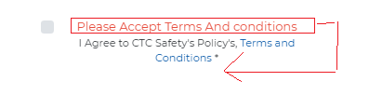
9. Organization user ->text after DOB and secondary email fields are missing.
10. Organization user -> change error message for “Secondary Email” to “Please Enter Recovery Email”
11. Organization user -> Please change ‘Secondary email’ to ‘Recovery Email’

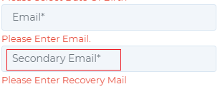

1. Organization user ->please change error message to “Please Enter Mobile no.”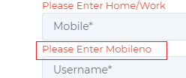
2. in “our Clients” section this dots are missing.**Design**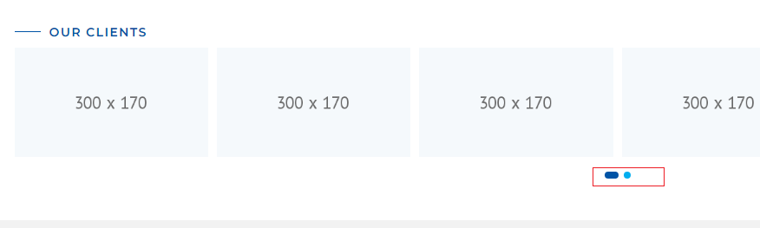

**Forgot password**

1. please remove down arrow in background.
2. Forgot password link is not sent to mail id .
3. when you 1st entered id then select type it gives error message “Email does not exists.”

**Sign up**

1. Home/Work Feild’s entry shows up in to Edit contact manager -> ‘Attention’ field of the postal address
2. Sign up -> Individual/student user -> Change success message to ‘SUCCESS! You have registered with CTC Safety.’ after successful registration.
3. Sign up -> Organization user -> success popup -> keep checkbox near ‘same as business address’



**Login**

1. change placeholder for this field to “Password”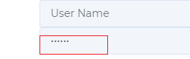
2. responsive view =please fix design in pop up **Design**

<http://dev6.wethedevelopers.com/MatthewYoung/final/#>

1. in “Giveaway” please fix image height in “Giveaway” section.**Design**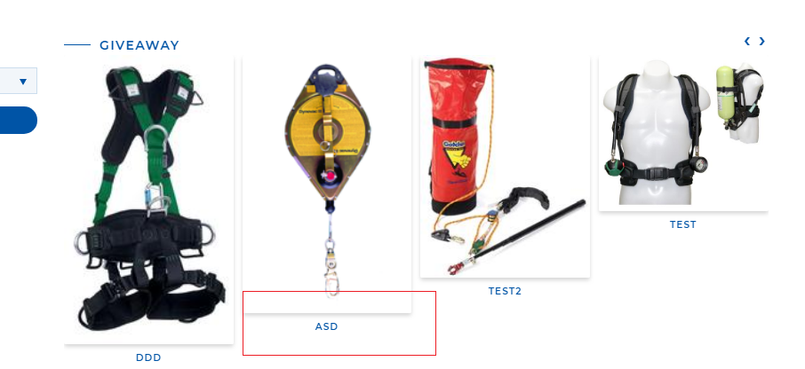
2. in “Giveaway” display products of active company.
3. in “Find A course” change text to “Select Industry” and “Select Location”.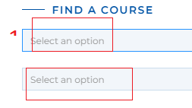
4. in responsive provide contact number ,search field,login button and language drop down.
5. iphone x pixel 2xl ->fix header .**Design**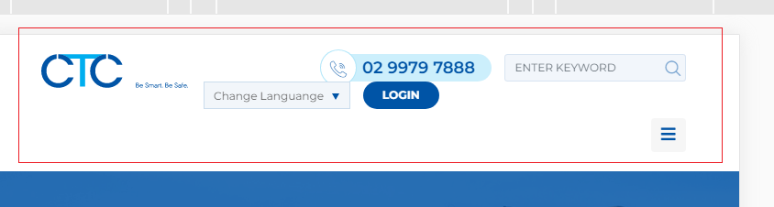
6. responsive = how to close sub-menu list.**Design**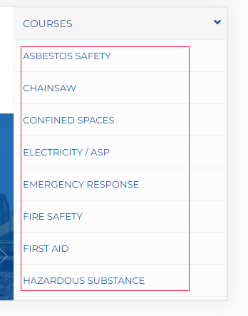
7. responsive = in “Find A Course” when you click on “Select month” date picker gets cut.**Design**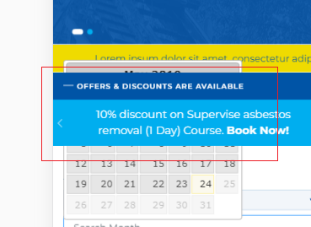
8. pixel 2xl ,iphone x (responsive) view = text “Select month” getting cut.**Design**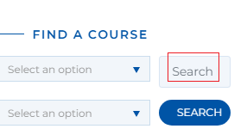
9. Responsive(galaxy 55 ,iPhone 6 & 6plus=> Landscape) => Please fix design of following slider **Design**

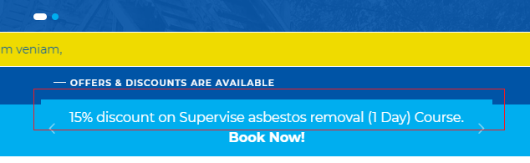

<http://dev6.wethedevelopers.com/MatthewYoung/final/course-categories/1/MTQ=/>

1. whichever category is open , it’s color in menu tab changed to white.**Design**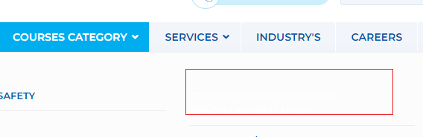
2. if you open same category again course listing changed every time.i.e it display courses of other category.
3. Category name is missing.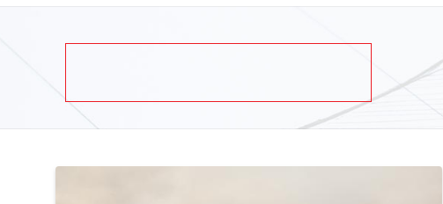
4. iphone 5 (landscape) view = put content in center.**Design**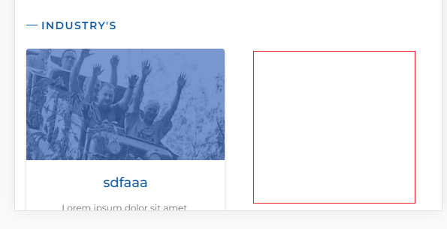
5. please remove this text.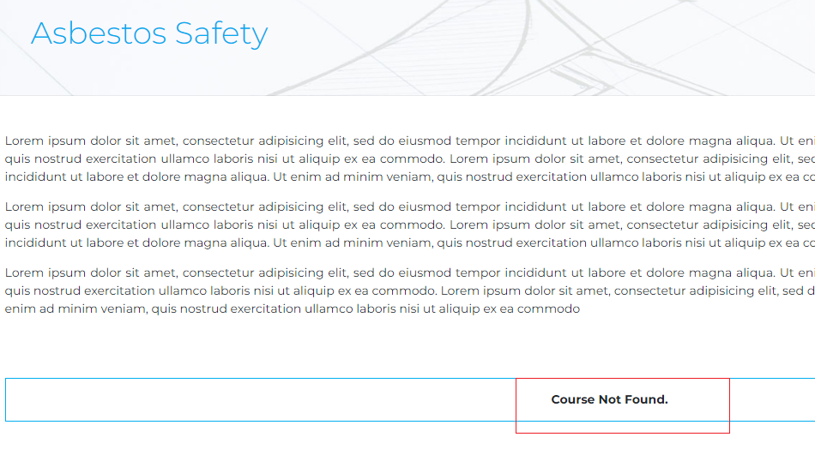

<http://dev6.wethedevelopers.com/MatthewYoung/final/course-industries/NDI=/1/>

1. add HR between Industry description and related courses **Design**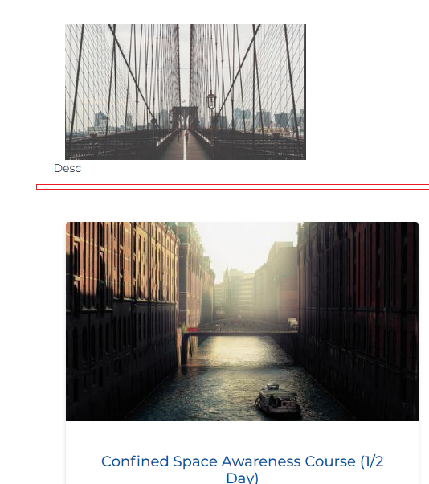

<http://dev6.wethedevelopers.com/MatthewYoung/final/industry/1>

1. change text to “Industries”.
2. remove this text.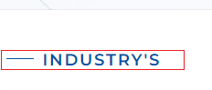
3. iphone 5 (landscape) view = put content in center.**Design**

<http://dev6.wethedevelopers.com/MatthewYoung/final/careers>

1. please put error messages outside of fields.
2. put error message after field.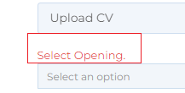and change message to “Select option”
3. phone number field should only allow digits.
4. responsive (landscape ) view= Placeholder text getting cut.**Design**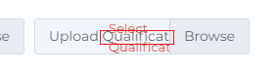
5. selected file name is not displayed in “upload cv” and “upload qualification”.
6. “select option” field should not be compulsory.

<http://dev6.wethedevelopers.com/MatthewYoung/final/news_details/Mw==>

1. please put back button at right side.**Design**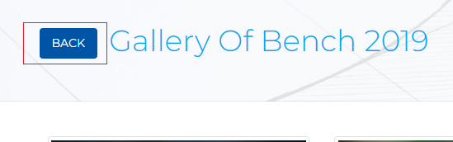

<http://dev6.wethedevelopers.com/MatthewYoung/final/gallery_category/1>

1. please make image size equal.**Design**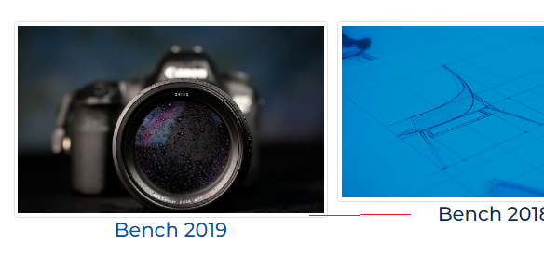

<http://dev6.wethedevelopers.com/MatthewYoung/final/our_clients>

1. iphone 5 (landscape) view = put content in center.**Design**

<http://dev6.wethedevelopers.com/MatthewYoung/final/course-industries/MzA=/1/>

1. mobile iphone 6/7/8(Landscape) view = please add space between buttons.**Design**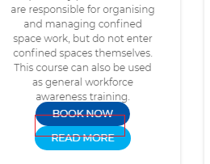

<http://dev6.wethedevelopers.com/MatthewYoung/final/course-industries/1/MzI=/>

1. Content text gets cut on left side for all industry detail pages **Design**

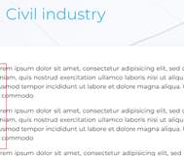

<http://dev6.wethedevelopers.com/MatthewYoung/final/news_details/Mg==>

1. Mobile view => Move News detail page images in center.**Design**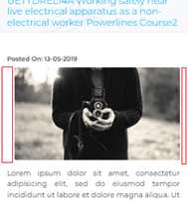

<http://dev6.wethedevelopers.com/MatthewYoung/final/our_clients>

1. Please center align client images.**Design** 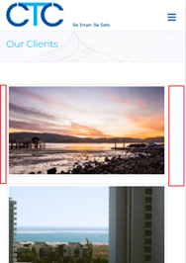

<http://dev6.wethedevelopers.com/MatthewYoung/final/search/>

1. design is not looks good**Design**

<http://dev6.wethedevelopers.com/MatthewYoung/final/privacy_policy>

1. correct spelling -> ‘Privacy Policy’

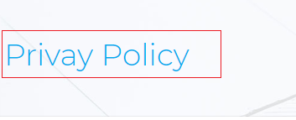

<http://dev6.wethedevelopers.com/MatthewYoung/final/resources>

1. Display documents/links in same order as they were added in admin library

**Course Detail**

<http://dev6.wethedevelopers.com/MatthewYoung/final/course-details/Ng==/1/Mjg=#course_dates>

1. please remove this button if no “Gallery ” is there.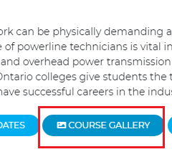
2. in group booking email id should be distinct from each other

<http://dev6.wethedevelopers.com/MatthewYoung/final/order_booking?token=EC-9UM48335VW607640H&PayerID=XGT7KBR9XY6BC>

1. change “Successfull Booking” to “Successful Booking”

<http://dev6.wethedevelopers.com/MatthewYoung/final/booking-terms/OQ==/1/MjAxOS0wNi0yOA==/Nw==/Nw==/MjM=>

1. sign up pop up -> mobile number and phone number , allow digits only
2. sign up pop up ek vaar close kari open kari pa6i organization and individual sign up na fields same aave chhe.
3. once you fill some details and close sign up pop up and again open pop up it displayed previously filled details.

++++++++++++++++++++++++++++++++++++++++++++++++++++++

**SITEADMIN 25may2019**

<http://dev6.wethedevelopers.com/MatthewYoung/final/siteadmin/manage_contact_manager.php>

<http://dev6.wethedevelopers.com/MatthewYoung/final/siteadmin/company_manager.php>

<http://dev6.wethedevelopers.com/MatthewYoung/final/siteadmin/manage_cms.php>

5. Also put placeholder ‘Search here…’ in search box

**Client’s Changes**

1. Adding Course Category and you can not have 2 or 3 word Keywords such as "Asbestos Removal" or "Asbestos Removal Training". Please align with google keywords.
2. the image SEO name also needs to have multiple fields like Keywords.
3. I need guidance on the image resolution and quality required. Images added as thumbnails in asbestos course category seem fuzzy on CSS
4. can not crop any portrait images, needs rotation
5. Course category module working well however change category position on website not working properly. Move up / move down.
6. In the Add unit group module when you press the + the new unit should add below not above the previously selected unit.
7. In add edit location Unit and building should be optional not mandatory.

==============================================================================

1. Calander ma date filter remove karyu chhe
2. snippets ma name add karvanu chhe?
3. Discounts baki chhe
4. calendar- functions of Marketing ,view bookings, manage bookings
5. company manager ->billes due,primary admin,administrator
6. group booking ma already login hoy eva user ni detail add kari to e contact manager ma new user padse to 2 login thase for same user.
7. offer name =course name , so course name editable rakhvanu k nai?/
8. qualification certificate -needs from client
9. xero api-needs from client
10. Invoice -needs from client